The New Berwick Maltings: A FLAWED PROPOSAL
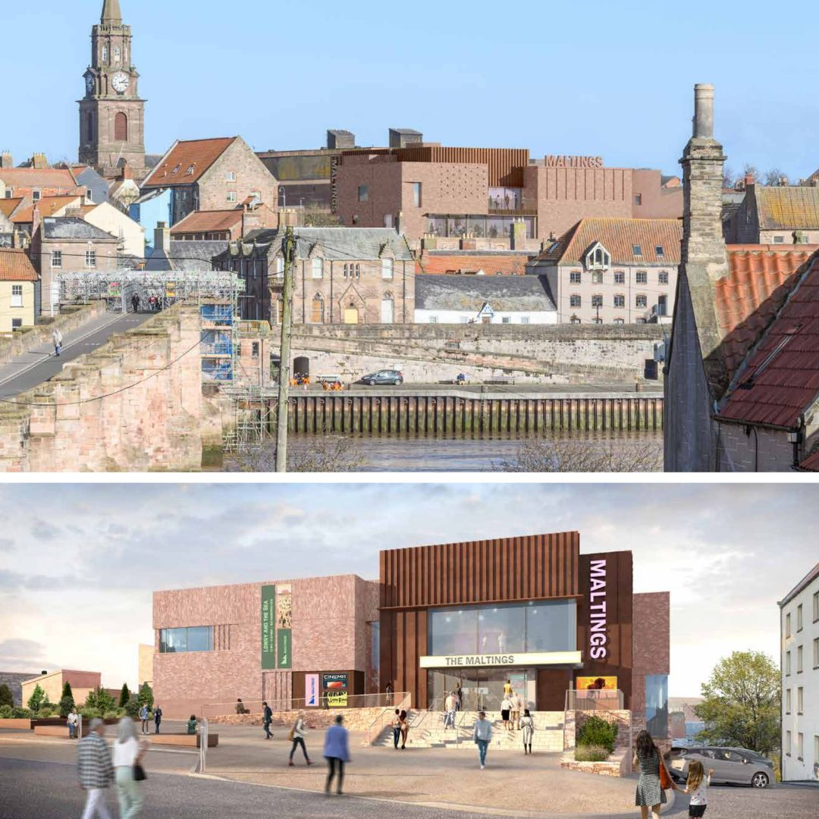
An analysis of the Berwick Maltings proposal and how it harms our town
by Julian and Harriet Smart, Berwick Heritage
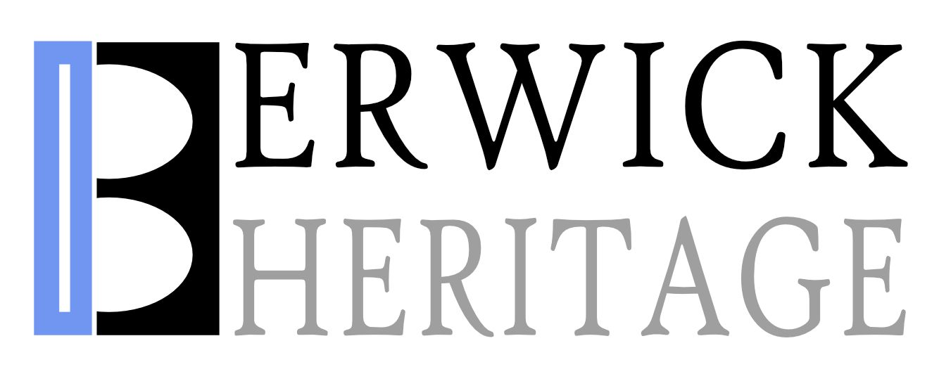

Published by Berwick Heritage
© Julian and Harriet Smart 2025
Version 1.1
Made with Jutoh
All rights reserved. This document may be freely distributed.
This proposal can be downloaded in a variety of formats from
www.berwick-heritage.co.uk/maltings or by using the QR code below.

Email: info@berwick-heritage.co.uk
Acknowledgements
Thank you to Katherine Tattersall for helping with the analysis of Historic England’s response.
Table of Contents
UPDATE ME

Summary

Overview
The Maltings Theatre redevelopment promises cultural and economic regeneration for Berwick-upon-Tweed through a modern, multi-purpose venue with £28.3m funding, including from the Borderlands Inclusive Growth Deal, Northumberland County Council, and Arts Council England. However, the proposal’s design, process, and projected benefits are deeply flawed, risking irreversible harm to Berwick’s heritage, community cohesion, and economic stability. This summary outlines key concerns.

Heritage at Risk
- The proposed taller, flat-roofed building with mainly modern materials (brick, Corten steel, large glazing, and render) and prominent “MALTINGS” signage clashes with Berwick’s Georgian and Victorian Conservation Area, harming key views (e.g., from Old Bridge) and the setting of Grade I listed assets like the Town Hall spire.
- The Heritage Statement admits “less than substantial harm” but downplays irreversible damage, failing to meet statutory duties under the Planning (Listed Buildings and Conservation Areas) Act 1990 and NPPF (December 2023) to preserve or enhance the area’s character.
- Flat roofs and signage lack historical precedent, creating a fortress-like structure that undermines Berwick’s historic roofscape and tourism appeal.

Inadequate Community Engagement
- Consultation reached only 2.5% of Berwick’s 12,000 residents (300 attendees over 12 hours across two phases), with no targeted outreach to diverse groups.
- Support dropped from 82% (July 2024) to 63% (January 2025), with 22% dissatisfaction ignored. A petition opposing the scheme has over 500 signatures, surpassing consultation attendance.
- Feedback on parking, flat roofs, and sustainability (e.g., solar panels) was dismissed, eroding trust and sidelining residents’ voices, contrary to NPPF Paragraph 39.

Overstated Economic and Social Benefits
- Claims of 135,000 annual visitors by 2030 (a 125% increase from 60,000 tickets year), 6 Full Time Equivalent jobs, and 100 further jobs in the wider community, lack economic modelling or market analysis, relying on optimistic assumptions.
- The business plan appears to be heavily dependant on cinema attendance. Cinema attendance was already low before the pandemic, and has not even reached those levels since. There is still considerable risk in the market due to cost to the consumer and changes of habit (such as preference for streaming plans).
- No clear vision or details are given of how the new theatre facility will be marketed to deliver this “step-change” in attendance, or how lasting audiences will be built. More information ought to be forthcoming in order to allow decision makers to better assess risk of tax payer investment.
- Seasonal tourism and a 2025-2027 closure further risk audience loss.
- Wider economic trends are uncertain and cost of living rises continue to make the public prioritise essential spending over entertainment.
- Social benefits claimed seem slight, given that most of the Maltings activities will be on a paying basis and therefore alienating to those on limited incomes. The “vibrant cultural hub” concept and the Design and Access statement seems to imply that the Maltings will become an outstanding meeting place, a sort of indoor public forum, but the stark utilitarian aesthetic of the spaces inside the building look extremely unwelcoming especially to non-paying customers.
- This weak public benefit argument is being used to justify the admitted harm to the historic skyline and the subsequent damage to Berwick’s reputation as an unspoilt historic town.

Environmental Shortcomings
- An 18.4% carbon reduction is modest compared to net-zero goals, with photovoltaic panels omitted despite community requests and feasibility.
- A 12.6% biodiversity net gain (0.02 units from rain gardens, two trees) is trivial, offering negligible ecological benefit near the Tweed Estuary SAC/SSSI.
- These gaps fail to align with Northumberland Local Plan Policy STP 4 and NPPF sustainability objectives.

Traffic and Accessibility Challenges
- Loss of 19 parking spaces (from 26 to 7) with only 8 cycle spaces and a drop-off area is inadequate for 135,000 projected visitors, particularly for elderly or disabled residents in a car-dependent town.
- Increased traffic from servicing and construction will cause congestion and disturbance.
- Community concerns about parking were ignored, undermining accessibility claims.

Harm to Wellbeing and Tourism
- The proposed design threatens Berwick’s tourism by spoiling iconic views, central to its “unspoilt” historic appeal, potentially reducing visitor numbers and local spending, the very thing the building is supposed to increase. Studies have show that visitors place a high value in heritage participation – notably £1,646 per person per year (2014).
- Flat roofs may exacerbate bird nuisance, adding to maintenance costs and degrading the town centre’s quality of life.
- Heritage loss impacts wellbeing, both real and perceived. Studies conservation areas boosting property values by 9%, indicating a strong preference for preserved and historic landscapes, and that such environments contribute a real value to daily life.
- Local reactions, although one might consider them subjective, suggest real distress at the proposed designs.

Procedural and Transparency Failures
- The 2019 feasibility study, costing £121,274, justifying the “not fit for purpose” claim, remains withheld despite public requests, hindering scrutiny.
- The RIBA architectural competition lacked transparency, with a conflict of interest (AHMM’s inclusion under RIBA president Simon Allford), no heritage experts or elected representatives on the jury, and no public disclosure of competing designs.
- Visualisations in the Design and Access Statement are inconsistent, with some views (e.g., Dock Road) using unclear red outlines, obscuring the building’s true impact.

Recommendation
The Maltings redevelopment fails to balance its promised public benefits against the significant harm to Berwick’s heritage, community, and economic stability, as required by NPPF Paragraph 202. Councillors should reject this proposal and direct the Maltings Trust to pursue a new design which will enhance facilities while preserving Berwick’s historic character.

1. Introduction: Unveiling the Proposal’s Shortcomings
This is the story of a missed opportunity.
The Maltings arts centre was built and opened in 1990s in the shell of a burnt-out Victorian maltings slap bang in the middle of Berwick with marvellous views across the river. A firm of architects from Edinburgh, Law-Naismith and Dunbar, was employed to do what they could on a tight site. Although there were some grumbles from local theatre owners and cinema operators, the general feeling was that Berwick needed an arts centre. A model was made and put on show and seemingly nobody objected. Costs rose obviously – they always do in these projects – but when the building was opened by Lord Palumbo there was a general feeling of civic pride and achievement.
This was because the building was beautifully done. Modest and quiet, it takes the spirit of an old maltings and with a touch of postmodern flair and considerably ingenuity creates a building that is perfect for its awkward setting. It was celebrated by the architectural profession and won a RIBA award, the judges commending the ingenuity and cleverness of the design.
So Berwick settled down with its new Art Centre and the building became what we would now call a hub for cultural activities in the town. The café became a popular meeting place. The council, which owned the building, handed the management and day-to-day operations of the building over to a charitable trust, The Maltings Trust, that had an educational remit. The centre flourished.
In 2011 some renovations were done and the function room was transformed into a flexible rehearsal space and studio theatre called the Henry Travers Studio. Things seemed to be going fine. There were a few grumbles about operational difficulties and costs, culminating in a 2016 a report that suggested that a quarter of a million pound renovation would bring everything up to scratch and do a great deal of local good.
But there were other forces at work. Politics got involved. The Borderlands Partnership was formed in 2014 in Peebles, a coalition of five councils: Cumberland, Dumfries and Galloway, Northumberland, Scottish Borders and Westmorland and Furness. The aim at first was to discuss shared economic opportunities and challenges, and these authorities continued to work in partnership, leading in 2017 to the Borderlands Inclusive Growth Proposition being submitted to both the UK and Scottish Governments. After years of further development work the Borderlands Inclusive Growth Deal was signed in March 2021, bringing up to £452 million of fresh investment to the Borderlands area.
Included in the plan’s major infrastructure is this:
“The new Maltings Venue will be an iconic, multi-purpose cultural and entertainment complex, transforming the appeal of Berwick-upon-Tweed as an attractive, high quality visitor destination. Up to £15 million of Borderlands funding, subject to full business case approval, will be invested from the UK Government together with £2.5 million from Northumberland County Council and £0.2 million from Arts Council England, to create a new major attractor to Berwick.
The uplift in scale and configuration of the existing facilities will create a high-quality attraction that will be a major draw, delivering a step change in audience numbers and making a significant contribution to increasing visitors to Berwick-upon-Tweed. A larger auditorium will attract larger touring productions and higher profile headline live performances; with a dedicated, authentic cinema also part of the offer. The new environment will be highly accessible throughout, benefiting visitors and performers alike.”
(https://www.borderlandsgrowth.com/_files/ugd/ac19f6_7fc03fb928924516a1a6b13bfed87a61.pdf)
How could any small arts charity in a provincial town, or its local authority owners, resist such a lure?
Suddenly the Maltings building was declared “not fit for purpose” and the elaborate, long drawn out scheme to replace it began to unfold. Advance Limited, the arms length development company attached to Northumberland Council, was put in charge of the development, and two of its executives were appointed to the committee which would judge the strangely conducted architectural competition. An architectural brief appeared and stated:
“This project will provide a landmark building and high-profile visual symbol of the impact of the Borderlands Inclusive Growth Deal. The new Maltings will also act as a key driver for the culture-led regeneration of Berwick-upon-Tweed – and a significant catalyst for economic growth, job creation, renewed civic pride, destination tourism, creative and commercial development.”
Also stated was an aspiration for the building to be “an architectural beacon overlooking the River Tweed and visible from the Royal Border railway bridge and East Coast Mainline train route” (taken from the Maltings web site).
The designs for this building were finally published on the Northumberland Planning Portal in March 2025 (application 25/00792/CCD), and it is these documents that this report intends to examine. Although the legal requirements of planning law and policy are carefully observed (the result of all necessary documents having been procured through many expensive consultants) the proposal contains many inflated claims that must be challenged.
The truth is that the lure of the Borderlands funding has resulted in a rushed, flawed proposal that, if permitted, will not bring the benefits it claims but rather will harm Berwick irrevocably.

2. Heritage at Risk

2.1. Introduction
The Maltings Theatre redevelopment proposal threatens to destroy Berwick-upon-Tweed’s historic character, a town renowned for its Georgian and Victorian architecture, medieval town walls, and dramatic river estuary setting. As a designated Conservation Area, Berwick is protected under the Planning (Listed Buildings and Conservation Areas) Act 1990 and the National Planning Policy Framework (NPPF, December 2023), which mandate that planning decisions must preserve or enhance the area’s unique character and appearance.
Despite these protections, the proposal introduces a taller, contemporary building with flat roofs, modern materials, and prominent signage that starkly contrasts with Berwick’s historic fabric. The Heritage Statement, prepared by Simpson & Brown, admits to “less than substantial harm” (Section 3.3) but downplays the irreversible damage to key views and the setting of Grade I listed assets such as the Town Hall spire (Section 3.6).
This section examines how the proposal’s design flaws and inadequate mitigation fail to meet statutory duties, putting Berwick’s heritage at significant risk.

2.2. The legal framework
A Conservation Area is a designated zone, typically in a town or village, recognized for its special architectural or historic interest, where extra planning controls apply to preserve or enhance its unique character and appearance. The planning controls are as follows.

The Planning (Listed Buildings and Conservation Areas) Act 1990
The 1990 Act is the primary legislation governing listed buildings and Conservation Areas in England and Wales. It imposes specific duties on local planning authorities (and others) regarding heritage assets. Section 72(1) deals with Conservation Areas and states:
“In the exercise, with respect to any buildings or other land in a conservation area, of any functions under or by virtue of [planning legislation], special attention shall be paid to the desirability of preserving or enhancing the character or appearance of that area.”
So the key phrase here is: “Preserving or enhancing the character or appearance.” This places a statutory duty on local authorities to give “special attention” to Conservation Areas when making planning decisions. “Preserving” means maintaining the existing character or appearance, while “enhancing” implies improving it. The “or” indicates flexibility – either outcome is sufficient, though both are desirable.
Section 66(1) – Listed Buildings also applies to Berwick. The text says:
“In considering whether to grant planning permission for development which affects a listed building or its setting, the local planning authority or, as the case may be, the Secretary of State shall have special regard to the desirability of preserving the building or its setting or any features of special architectural or historic interest which it possesses.”
The key phrase here is: “Preserving the building or its setting.” This is relevant because Conservation Areas often contain listed buildings (as in Berwick-Upon-Tweed). “Preserving” here again means maintaining, but there’s no explicit “enhancing” duty – though enhancement is often a practical outcome.
The Act uses “special attention” (Conservation Areas) and “special regard” (listed buildings), emphasizing heritage as a material consideration. Courts have interpreted these as strong duties, often outweighing other planning factors unless significant public benefits justify harm.

National Planning Policy Framework (NPPF) – December 2023
The NPPF provides national planning policy guidance for England, translating statutory duties into a framework for decision-making and plan-making. The December 2023 version (published 19 December 2023) is the latest full update. Chapter 16 (“Conserving and Enhancing the Historic Environment”) addresses heritage assets, including Conservation Areas and listed buildings. Here’s how “preserve and enhance” is expressed:
Paragraph 199: “When considering the impact of a proposed development on the significance of a designated heritage asset, great weight should be given to the asset’s conservation (and the more important the asset, the greater the weight should be). This is irrespective of whether any potential harm amounts to substantial harm, total loss or less than substantial harm to its significance.”
“Conservation” here encapsulates “preserving or enhancing.” It’s defined in the NPPF Glossary as “The process of maintaining and managing change to a heritage asset in a way that sustains and, where appropriate, enhances its significance.” This aligns with the 1990 Act’s dual aim, emphasizing protection and potential improvement.
Paragraph 200: “Any harm to, or loss of, the significance of a designated heritage asset (from its alteration or destruction, or from development within its setting) should require clear and convincing justification. Substantial harm to or loss of… designated heritage assets of the highest significance… should be wholly exceptional.”
This reinforces the “preserve” duty by setting a high bar for harm, indirectly encouraging enhancement where possible to avoid harm.
Paragraph 202 (Less Than Substantial Harm): “Where a development proposal will lead to less than substantial harm to the significance of a designated heritage asset, this harm should be weighed against the public benefits of the proposal, including, where appropriate, securing its optimum viable use.”
This means that if a proposal can’t fully “preserve” (i.e., causes some harm), enhancement elsewhere (e.g., public benefits like cultural venue improvements) can justify it. This reflects the Act’s flexibility.
Paragraph 206 (Conservation Areas Specifically): “Local planning authorities should look for opportunities for new development within Conservation Areas and World Heritage Sites, and within the setting of heritage assets, to enhance or better reveal their significance. Proposals that preserve those elements of the setting that make a positive contribution to the asset (or which better reveal its significance) should be treated favourably.”
Key phrases are “enhance or better reveal their significance” and “preserve those elements.” This directly echoes the 1990 Act’s “preserve or enhance” duty, urging proactive enhancement (e.g., improving visibility or context) alongside preservation. It encourages positive planning decisions that align with the statutory goal.
Since this is a well-resourced application, there have been strenuous efforts to show that what they desire to do aligns with the statutory framework, and they have commissioned documents to prove it. The Heritage Statement is the most important here. In this case it has been written by a firm in Edinburgh, Simpson & Brown, a firm of architects and heritage consultants.
This is their own definition of the function of a Heritage Statement.
“A Heritage Statement is a document required when seeking planning permission involving a heritage asset. A Heritage Statement will accompany a planning application and will describe the history and significance of the relevant heritage asset or assets. It will describe the proposed works and their potential impact. Heritage Statements seek to justify the proposed works in order to ensure that the important aspects of a heritage asset are preserved for the future.” (www.simpsonandbrown.co.uk/heritage-consultancy/heritage-statements/)
Therefore, one must regard a Heritage Statement as an advocacy document, paid for by the client, in order to justify the development. It should be read in that light.

2.3. Threat to historic character
As we have seen, the NPPF demands that:
“When considering the impact of a proposed development on the significance of a designated heritage asset, great weight should be given to the asset’s conservation (and the more important the asset, the greater the weight should be). This is irrespective of whether any potential harm amounts to substantial harm, total loss or less than substantial harm to its significance.”
The Heritage Statement accompanying the proposal admits: “The result will be a taller, more contemporary building in the conservation area in entirely different materiality” and “All views towards the building will change.”
When studying the visualisations provided in the Design and Access Statement, one can see that the proposal will case irrevocable changes that threaten the much-loved views over the roofs of Berwick and the setting of key heritage assets like the Grade I listed Town Hall spire. Their statement further acknowledges:
“The most sensitive elements of the conservation area which will experience change as a result of the proposed development are key views towards Berwick when approaching from the south. Views from Old Berwick Bridge (visualised as part of the application, view 0117), from the Royal Tweed Bridge (view 0142) and from Union Brae, Tweedmouth (view 0143) provide panoramic views across Berwick’s dense roofscape.”
It goes on to discuss now the existing Maltings building preserves these views with its similar height, clay pantiles, and pitched roof broken into sections, reflecting the lack of large, single-roofed buildings in these vistas, and then states that “the proposed scheme also looks to preserve this view.” However, it immediately contradicts this by admitting the new building “will be more visually prominent, as it will be taller, more contemporary, and have flat roofs.”
If the new design takes its cues from anything local, it seems to be from the Sports Direct building and from sheds such as the Food Warehouse, as the following illustration shows.
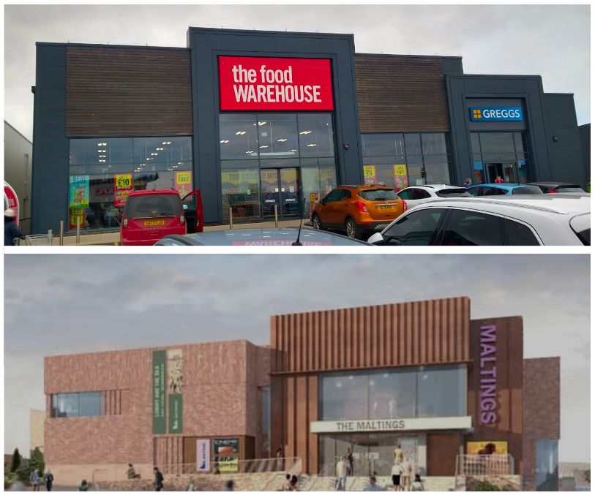
Inspiration from local architecture?

2.4. Design flaws: incompatible and insensitive
The most obvious feature of the design at odds with the setting are the flat roofs. These are justified in the proposal as a means “to reduce the height of the proposed building as far as possible while maintaining the functionality of the internal spaces” (e.g., a 280-307 seat theatre and cinema spaces). However, this is a flawed compromise. While they may lower overall height compared to a pitched design, they create a stark contrast with Berwick’s traditional pitched-roof skyline, as noted in the Heritage Statement’s own description of the conservation area’s “vertical rhythm.”
The Design and Access Statement exhaustively details these internal requirements, but the proposal provides little evidence that alternative designs – such as pitched roofs with adjusted internal layouts – were seriously explored to better align with Berwick’s character.
The Energy Statement’s focus on operational efficiency offers no heritage offset, leaving the flat-roof decision as a functional choice rather than a heritage-sensitive one. The flat roof was adopted to accommodate the air source heat pumps and the raised brick parapet (and implied increased height) is there to conceal the plant from the view.
This decision to prioritise function makes the building from the riverside as massive and fortress-like, but without any visual clues as to its function, other than the crass signage. Although claims are made about the blocks being broken up to create a less obtrusive composition, the impression is still one of a lumpen mass of cuboids dumped on top of the townscape.

2.5. Material choices
The choice of materials further disrupts the existing composition. The architects claim to be “bedding in” to Berwick with their choice of tumbled rose and grey brick and small areas of local Doddington stone. The Heritage Statement asserts that the brickwork “reflects the local vernacular” (Section 3.12) and the architect claims it “matches tones of the local stone” (Material Palette), yet the “variation in coursing and relief detailing” (Design and Access Statement) still prioritises a contemporary look over the traditional brick bonds and detailing typical of Berwick’s historic buildings.
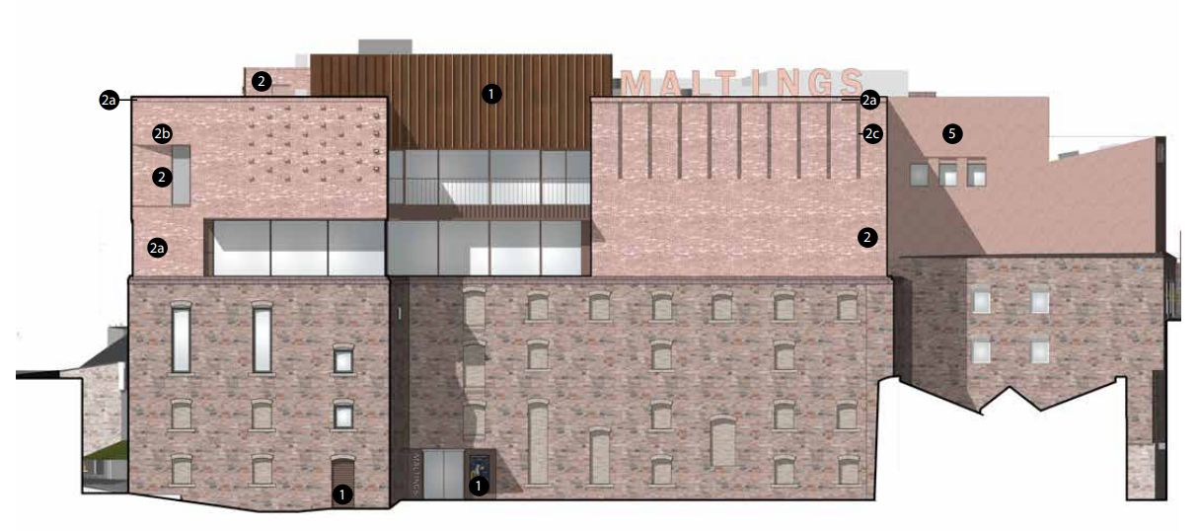
South side of the building showing Corten steel (1), brick (2), and render (5)
Most of the rest of the building will sport large expanses of unframed glazing, and weathered Corten steel cladding. These have no historical precedent in Berwick’s Georgian and Victorian fabric and do not enhance the conservation area. Nor does the metal “brise-soleil,” introduced to reduce heat in the café area – a purely functional choice, not a traditional form, and entirely out of place in this historic architectural landscape.
Nearly a quarter of the new south side surface will be smooth render – marked as (5) in the illustration above – broken only by three small windows. This will be highly visible from some angles and will look particularly jarring.
Finally, the prominent “MALTINGS” lettering, described by the architect as “Large graphic architectural lettering [that] crowns the central form and adds variation to the roof profile,” dominates the view from the river. There can be no justification for such a feature, which is without precedent in the conservation area and seems to exist only to fulfil a desire to brand an expensive building in a vulgar fashion.

2.6. Responses from heritage organisations
Although this section is not commentary on the application itself, it’s worth looking at what local and national heritage have to say about it since their attitudes impact on the protection of our heritage.

The Berwick Conservation Area Advisory Group (CAAG)
While this group does not have any statutory standing, nevertheless it represents a tick-box for the applicant’s consultation requirements. The county council is obliged to consult local groups and therefore CAAG should represent residents’ feelings about whether the application adversely affects the conservation area. CAAG aspires to protect Berwick’s heritage and its conservation area and in our opinion, it has failed in its remit here. CAAG say in their response to the application:
“CAAG further supports the Heritage Statement which concludes that the Berwick Conservation Area would suffer less than substantial harm from implementation of the proposals. This is considered acceptable when weighed against the benefits for the town.”
We have heard from within CAAG that the acceptance is due in large part to fear of losing the taxpayer funding for the project. The only conclusion that can be drawn from this as that our conservation area is highly vulnerable to the promise of money. Considerations that would normally apply to the resident or business simply do not apply when powerful forces are involved. CAAG therefore offers the town no significant protection in this case.
It is also worth mentioning that CAAG’s stance is not unanimous. One long-standing member has objected strongly to the design.

The Berwick Civic Society
The Berwick Civic Society, too, seems to have forgotten its own remit, which is described on its own website thus (our emphasis):
1. Judgements will be primarily aesthetic and not social or political.
2. The Society has a duty of care for the listed buildings in its area of responsibility. It will therefore:
...
e) Oppose any development which affects the setting of a listed building, to its detriment.
3. The Society has a duty of care for the Conservation Areas within its area of responsibility. It will therefore:
a) Oppose any development within the Conservation Areas, which by virtue of its scale, height or massiveness is not in keeping with other buildings in the area.
...
c) Oppose any development which is not of a suitable quality for its location. Quality may refer to architectural style or the materials used for construction.
...
e) Encourage initiatives to maintain and enhance the town’s natural environment and its unique character.
4. The Society will oppose any development which will detract from the natural beauty of the coastline and the Tweed Estuary since these together with the Town’s special history are considered as Berwick’s most important assets.
The proposed development cuts across all of these aspirations. Again, the momentum of the Maltings plan and its claimed benefits seems to be the main reason why the building is not being judged as would, say, a large retail outlet. The Civic Society’s supporting statement says:
“Funding for a major new arts centre in a small and relatively remote coastal town like Berwick is a rarity and attests to the reputation the Maltings has built in the two generations since it was established. We cannot risk losing this investment.”
This reads like a judgement about social impact, explicitly ruled out in point (1) above.
It is notable that the current chair of the planning committee at the Civic Society is a modernism enthusiast, and also sits on both CAAG and the Maltings’ informal advisory group. This constitutes a high degree of influence in organisations that are not representing wider views within Berwick.

Historic England
Historic England has an ambiguous role in this application. A 2022 letter from them urged the participants in the Maltings project to play down the parts of the architectural brief that expressed a desire for a beacon advertising the Borderlands funding body (see Appendix A: Maltings Timeline). This seems precisely what the public might expect of Historic England in protecting a setting of national significance.
Fast forward to 2024, and Historic England is advising a flat roof because the more popular design with pitched roofs was “incongruous”. Furthermore, Historic England offers no objection at all to the application (reproduced in full in Appendix D), saying that the building will “add to the already rich architectural landscape of the town” and – extraordinarily – that it will make a positive impact on the character and appearance of the conservation area. In this, they go further than even the applicant’s Heritage Statement, which admits to some harm.
The architect is at great pains in the application to emphasise Historic England’s role here, and at the 2025 consultation repeatedly stated that Historic England wanted the building to “look modern.” This stark contrast may indicate personnel differences within the organisation, or perhaps the softening effect of being a consultant on the project and making concessions, especially to fellow government organisations. We have been in conversation with Historic England and have failed to get satisfactory answers for exactly why they are so accepting of the design. Ideology favouring modernism – by no means an uncontroversial and settled architectural preference in the UK – must be a factor.
Whatever the motivation, the end result is to remove another layer of protection for Berwick’s historic skyline and some of its most cherished views.
These are our detailed criticisms of Historic England’s consultee response on the portal and included in this report (Appendix D).

1. Excessive focus on ‘use’ rather than ‘context’
The emphasis is on the architectural needs of a modern arts centre rather than preservation of the conservation area character – the opposite of what one expects Historic England to prioritise. The function of the building is considered to be the overriding concern, not its context. Hence the generalisation about “new arts centres around the country” as though one should accept there is a standard offering rather than a bespoke option for the individual setting.

2. Championing contrast
Referencing local architectural distinctiveness (a fundamental requirement for new development in conservation areas) has been abandoned in favour of championing obvious contrast. The attitude to the existing Maltings building (prizewinning for being sympathetic to the setting) is in effect ‘good riddance’. This is consistent with Scott Sherrard’s public statement that there was a deliberate decision to stand out rather than blend in.

3. Approval of a prominent distraction in an iconic historic vista
Having a dominant presence, rather than linking well into the context, is sold as a desirable outcome as opposed to a potential problem in the panorama of the estuary.

4. Questionable interpretation of the meaning of the concept of ‘enhancement’
The message is that looking at something different and highly noticeable inevitably counts as ‘enhancement’ in a conservation area. This is a highly questionable interpretation of the meaning of enhancement, as required by laws protecting conservation areas. We cannot see any credible justification for the conclusion that the new building ‘makes a positive impact upon the character and appearance of the conservation area.’ We disagree with the verdict that the design achieves a balance between distinctiveness and suitability for the context.

The Victorian Society
The Victorian Society – a statutory consultee by virtue of the Maltings’ 19th century base – has lodged an objection to the proposal, saying:
“The introduction of such a disruptive building would completely unbalance this conservation area, harming significance and a key view of Berwick looking East. The design is inappropriate to the Conservation Area; it is not a responsible answer to the character and appearance of Berwick-upon-Tweed. In conclusion, the Society recognises the need for an updated and accessible community hub, but objects to the design and form of the proposal. It is both inappropriate and harmful to Berwick’s Conservation Area.”
The Society, then, is one of the few organisations that appreciates the importance of the setting and harm that will be done to it.

Historic Buildings and Places
This organisation (formerly the Ancient Monuments Society) expressed concern over the intrusiveness of the proposed signage.

The Georgian Group
The Georgian Group, while not a statutory consultee in this case, nevertheless takes an interest in the partly Georgian setting around the Maltings site. Like the Victorian Society, they are worried, and say:
“The Group registers concerns that the bold and assertive design for the new Maltings Theatre has the potential to cause considerable harm to the integrity of the historic character of the Berwick upon Tweed Conservation Area, and to the setting of the Grade I listed Town Hall and other nearby listed heritage assets.”

2.7. Harm: a major threat to Berwick’s historic legacy
The Maltings redevelopment places Berwick’s heritage at significant risk, failing to meet the statutory duty to preserve or enhance the conservation area’s character. The design’s incompatible features – flat roofs, modern materials, and prominent signage – irreparably harm the town’s historic roofscape, key views, and the setting of listed assets like the Town Hall spire, as seen in the visualisations. This proposal prioritises functionality and branding over Berwick’s historic legacy, disregarding community concerns and offering no meaningful mitigation.
Compounding the potential harm and underscoring the pervasive failure to take heed of heritage concerns, Berwick Town Council issued a mere 13-word supporting comment. It gave unqualified support to the proposal without mentioning the more than 70% dissenting voices in the special public meeting they themselves convened. Berwick’s own conservation groups offer little divergence from the stance of the Maltings’ own stakeholders and will not press for significant design improvements. By contrast, the Victorian Society and Georgian Group recognise the damage that will be done to the historic setting and conservation area.

3. Inadequate Community Engagement

3.1. Introduction
A planning proposal for a scheme of this size and nature requires the developer to show that the community have been properly engaged in shaping the look and feel of the development.
Paragraph 39 of the NPPF states:
“Early engagement has significant potential to improve the efficiency and effectiveness of the planning application system for all parties. Good quality pre-application discussion enables better coordination between public and private resources and improved outcomes for the community.”
The process of ‘pre-application discussion” is presented in a document called a “Statement of Community Engagement” (SCE). The Maltings Trust instructed a firm in Glasgow, North Planning and Development, to prepare this.
“North Planning & Development provide trusted advice to developers, investors and occupiers in both the public and private sector. Our services are informed by our insight, commerciality, professional experience and research.North Planning & Development provide trusted advice to developers, investors and occupiers in both the public and private sector. Our services are informed by our insight, commerciality, professional experience and research.” (www.northplan.co.uk/)
This firm is also acting as the agent for the planning proposal, and is clearly an important cog in the whole proposal machine.
The Maltings Theatre redevelopment proposal claims to have engaged the Berwick community through an “extensive and comprehensive programme of consultation” asserting that this process reflects the town’s voice and has shaped the project’s design. However, a closer examination reveals a deeply flawed engagement effort that fails to represent the community’s true sentiments, ignores critical feedback, and ultimately erodes trust and silences the voices of Berwick’s residents.

3.2. Limited consultation reach – poor engagement with the general public
The Statement of Community Engagement documents a consultation process spanning two phases (July 2024 and January 2025), involving four public exhibitions that attracted approximately 300 attendees (Section 3.2). These are described as “a number of well-attended public exhibitions at the existing Maltings Theatre on the 20th and 24th of July 2024, and the 25th and 27th of January 2025.”
The first phase took the form of an exhibition at the Maltings which was open for a total of five hours, over two sessions on the 20th and 24th of July. The proposals were also made available in the form of a 6-page PDF which could be downloaded. People were invited to submit comments online between August 2nd and August 19th.
The second public exhibition was held in January 2025 for seven hours. The event took place in the bar at the Maltings but was not signposted from the foyer. Feedback forms were provided, but no pens or places to sit and write. The proposals were displayed on boards with very few exterior images. The impact of the building and the changes since the last public display are however still notable. It is described on the website as a “pre-planning consultation”.
The 2024 and 2025 public consultation made the designs available in physical form for a combined 12 hours.
If one takes that estimate of 300 attendees over both events, in a town of 12,000 residents (Planning Statement, p. 4), this represents a mere 2.5% of the population – a strikingly low figure for a project of such scale and impact. One must also note that out of those 300, a proportion would be ‘repeat offenders’, so to speak, so the actual attendance may be considerable lower than 300. (At the public exhibition we attended in January 2025 no effort was being made to count people as they came in.)
These public consultation events, held over six months, were limited with no clear evidence of targeted outreach to diverse groups such as younger residents, low-income families, or those with accessibility needs, despite Berwick’s demographic challenges like low wages and limited education facilities (Planning Statement, Page 6). Online feedback channels (Section 1.4) are mentioned, but the SCE provides no data on their uptake, suggesting they were underutilised or ineffective. This narrow reach starkly contrasts with the project’s claim of being a “cultural hub” for all of Berwick (Planning Statement, p. 4), indicating a consultation process that was more performative than inclusive.

3.3. Declining support and unaddressed dissent
The SCE touts a 72.5% average support rate derived from responses to the public exhibitions, but this figure masks a troubling decline in community approval. Initial support in July 2024 stood at 82%, dropping to 63% by January 2025. This is a 19% decrease that reflects growing scepticism as the design changed. Moreover, 22% of respondents expressed dissatisfaction, a significant minority that the SCE downplays by focusing on the “significant majority”.
The 448 total responses across both phases amount to just 3.7% of Berwick’s population (assuming unique respondents), again lacking demographic breakdown to prove representativeness. This limited sample, combined with the decline in support, undermines the claim of “strong community support”. In contrast, our petition opposing the redevelopment has garnered over 500 signatures, surpassing the SCE’s attendance and signalling widespread dissent that the proposal fails to acknowledge or address.

3.4. Ignored feedback
The SCE’s assertion that feedback “informed design evolution” is not borne out by the evidence. Respondents raised valid concerns about parking, the modern flat-roofed design, and the lack of renewable energy like solar panels. Yet the final design shows that they increased the area of flat roof, despite people supporting the original pitched roof design.
The 448 responses are a small fraction of the population, and the SCE provides no evidence of engaging under-represented groups, such as those with disabilities. The limited school workshops do little to broaden this reach, leaving the consultation unrepresentative and dismissive of critical feedback.

3.5. Unquantified stakeholder consultation
Aside from these public exhibitions the claim is made that:
“As part of the planning process for the site, the applicant has undertaken an extensive and comprehensive programme of consultation. This included hosting a number of well-attended public exhibitions at the existing Maltings Theatre on the 20th and 24th of July 2024, and the 25th and 27th of January 2025, and there has been separate engagement throughout with other stakeholders and interest groups, including the Berwick Town Council, Civic Society, Chamber of Trade, Town Forum, and the Conservation Area Advisory Group.” (Section 1.2)
There is scant evidence provided of what these groups said, when and how they were questioned and whether their advice was acted upon.
Berwick Chamber of Trade is cited as an example of a stakeholder engaged to ensure the project aligns with local economic priorities, such as supporting Berwick’s service, hospitality, and retail sectors. This engagement is used to claim compliance with the Northumberland Local Plan, in order to suggest that the project’s economic benefits – 6 full time equivalent jobs and 100 wider jobs, and 135,000 visitors by 2030 – reflect local needs. The Chamber, representing local businesses, would be a key stakeholder in assessing economic impacts, particularly given Berwick’s reliance on tourism and retail. But the Planning Statement does not provide a specific opinion from the Berwick Chamber of Trade, only stating that engagement occurred. There’s no indication of whether the Chamber raised concerns or influenced the design – for example addressing the 19-space parking loss, leaving the claim vague and unsubstantiated.
There is also no evidence given of discussion with elected representatives such as local councillors.

3.6. Harm: erosion of community trust and voice
The inadequate consultation process has profound consequences for Berwick. By engaging only a small, unrepresentative portion of the population and ignoring significant feedback the proposal sidelines the voices of the majority, as evidenced by our 500+-signature petition. The decline in support to 63% (Section 4.2) and 22% dissatisfaction reflect a growing mistrust, exacerbated by the lack of transparency in addressing concerns like parking and sustainability.
This erosion of trust undermines the project’s claim to be a community-driven initiative (Planning Statement, p. 4), leaving residents feeling unheard and disenfranchised. The failure to genuinely engage Berwick’s diverse population not only harms community cohesion but also risks long-term opposition, as the project proceeds without a true mandate, threatening the social fabric of our town.

4. Overstated Economic and Social Benefits

4.1. Introduction
In order to get a design like the proposed New Maltings development through planning and build in a conservation area, it is necessary to show that the development is going to be beneficial to the public.
Historic England’s Guidance on Conservation Areas says:
“When considering proposals that cause harm to a conservation area, local planning authorities should weigh this harm against the public benefits of the proposal, as set out in the NPPF (Paragraph 202). Public benefits may include economic, social, or environmental improvements that deliver tangible advantages to the community.”
As a result, the Maltings Theatre redevelopment proposal promises a transformative array of public benefits, positioning itself as a catalyst for economic growth, cultural enrichment, and social enhancement in Berwick-upon-Tweed. The Planning Statement claims the project will deliver an “outstanding and innovative design” that provides a “step change in the quality and accessibility” of the Maltings, supporting culture-led regeneration with significant economic and social benefits. However, these claims are built on unsubstantiated projections, fail to address vulnerabilities in cinema attendance, and lack critical data to support their feasibility. The result is a proposal that overstates its benefits, exposing Berwick to financial risk and unfulfilled community promises, leaving residents with a costly venue that may fail to deliver on its ambitious goals.

4.2. Unsubstantiated job projections
The Planning Statement asserts that the redevelopment will create 6 full-time equivalent jobs (i.e. a mixture of full and part time jobs), as well as 100 wider jobs in the local economy.
The 6 FTEs and 100 wider jobs are not substantiated with economic modelling, revenue projections, or a breakdown of job types, sectors, or sustainability, especially in Berwick’s seasonal, tourism-driven economy.

4.3. Ripple effect to wider economy
The Planning Statement says:
“An increase in visitor numbers and spend will support additional employment opportunities, both at the New Maltings venue and in the wider visitor economy.”
There are no details of how this might work. The basic idea seems to be people will come to the town to see the latest Hollywood blockbuster, and spend additional money as a result. Again, mention of concessions such as a book shop or craft gallery in the new building might have been reassuring. Or perhaps a plan for street food stalls or a craft market outside the building?

4.4. Projected visitor figures
The Planning statement makes this bold claim:
“The proposed development will build on this success, delivering a new cultural facility that will attract 135,000 visitors a year by 2030, supporting the culture-led regeneration of Berwick-upon-Tweed.”
This projection is part of the economic justification for the redevelopment, claiming a 125% increase from the current 60,000 tickets/year. These figures are central to the project’s economic justification.
The Heritage Statement echoes this with a vague “commercial return for the town.” However, these claims lack any supporting evidence to justify their feasibility. This 135,000 visitor target is not backed by market analysis, demographic studies, or competitive assessments, leaving it as an aspirational figure rather than a grounded projection.
An email from Scott Sherrard to the Friends of the Maltings reinforces this optimism, claiming a “thrilling programme for change” but offers no data to support the economic benefits, highlighting the proposal’s reliance on unsubstantiated assertions.
The 135,000 target is broken down as follows:
“The Trust aims to attract 135,000 visitors per annum to the transformed facility by 2030. Of this, 65% will be visits by the local market, 15% from extended day trip market, and 20% from the tourist market, including 85,000 visits per annum to live performances, headline events and film screenings, and footfall to the new bar and restaurant footfall of c. 50,000 per annum.”
For an example of the lack of evidence, let us look at the projected bar and restaurant footfall. It seems strange to assert that there will be 50,000 visits to the bar and restaurant without more specific details of what sort of customers they are aiming to attract, and what they are proposing to offer. A restaurant with full waiter service, and a gourmet menu of locally sourced produce is going to attract a very different customer base than a child-friendly counter service café. The look and feel of the café areas are utterly unspecified. How are we supposed to accept this will be a sure-fire success with 50,000 visits a year (136 visits a day on average)? Perhaps if a celebrity chef had been attached to the project, we might have more confidence. This sort of information is crucial because it forms part of the exercise that the councillors must perform when weighing the benefit to balance the heritage harm caused.

4.5. Vulnerability to cinema attendance decline
The proposal’s economic and social benefits hinge on the success of two new cinemas – Cinema 01 (125 seats) and Cinema 02 (40 seats) – intended to operate daily. The RIBA brief envisions a “year-round festival/events programme to grow the evening economy”. However, this reliance on cinema attendance is a significant vulnerability, as the proposal ignores declining cinema-going trends and competition from digital platforms.
Post-COVID shifts show reduced cinema attendance due to streaming growth, changing demographics and rising ticket prices with independent cinemas struggling. In 2019 there were approximately 38,605 visits per screen available in the UK, but by 2022–23 this had fallen to 25,435–26,870, a trend driven by pandemic impacts, streaming, and demographic changes, as evidenced by Statista, UK Cinema Association, and European Audiovisual Observatory data.
Another risk factor in the emphasis on cinema is that over the last five years, major Hollywood studio theatrical releases have declined from a 2010–2019 average of 83 films per year, with 2023–2024 seeing from 60 to 80 wide releases annually from the five major studios. This decline is driven by the COVID-19 pandemic’s disruption, the 2023 writers’ and actors’ strikes, studio consolidation, shifting consumer preferences toward streaming, rising costs, and production migration to tax-friendly regions.
Berwick residents may choose to access larger, modern cinemas in Newcastle (60 miles, e.g., Odeon Metrocentre, 12 screens) or Edinburgh (50 miles, e.g., Vue Edinburgh, 8 screens), which offer wider film selections, premium experiences (e.g. IMAX and recliners), and competitive pricing (£7–£12). Travel is feasible via car or train (less than an hour), especially for families or young audiences seeking blockbusters.
The Maltings’ 125-seat cinema, focused on commercial films, may struggle to compete without unique offerings such as themed nights. The Maltings Trust gives no details of how they intend to build a cinema audience. Assuming no projector is installed in the theatre, the projected total cinema seating capacity (around 165) is well below what already exists, impacting on the Berwick Film and Media Arts Festival that uses the maximum capacity. The reduction in capacity also raises questions around attracting mainstream first releases.
The 19-space parking loss could deter visitors, further threatening attendance. The 2025-2027 closure and problems with the projector at the temporary venue risk shifting audiences to digital platforms, with no retention strategy clearly outlined that might ensure post-reopening attendance. The lack of risk assessment – for example, no contingency for attendance drops or cost-per-visit analysis – leaves the project exposed to possible failure, undermining the promised cultural access.

4.6. Dependence on seasonal tourism
Berwick’s economy is “largely dependent on services, hospitality, and retail, tailored in particular to a seasonal visitor market”, a reality the proposal fails to address in its visitor projections. The 135,000 annual visitors assume year-round attendance, but Berwick’s seasonal tourism, peaking in summer and dipping in off-seasons, poses a significant risk to this target. The RIBA brief aims for a “year-round festival/events programme to grow the evening economy and lengthen the visitor season” but provides no evidence of event frequency, demand, or off-season strategies to sustain attendance. The Heritage Statement’s focus on the building’s prominence and the DAS’s public square offers no mitigation for seasonal dips, as seen in the visualisation of a sparse and stark forecourt. The proposal lacks a detailed visitor strategy, such as how it will expand local audiences and deal with seasonal fluctuations, risking low attendance and revenue shortfalls.

4.7. Closure period uncertainties
The Planning Statement notes a 2025-2027 closure period during construction with the plan to move to a temporary cinema at Berwick Barracks (96 seats) to “keep the show on the road” as the chairman notes in his email. However, this closure introduces significant uncertainties that the proposal fails to address. The current 60,000 tickets/year will be disrupted for at least two years, risking audience loss to digital platforms or competing venues. The temporary venue may not match the Maltings’ appeal, and the email’s mention of “fewer tickets to sell” acknowledges this risk without offering a retention strategy. The proposal in general makes light of interim impact, leaving the project vulnerable to a permanent audience shift.

4.8. Vague social benefits
Social benefits claimed seem slight, given that most of the Maltings activities will be on a paying basis and therefore alienating to those on limited incomes.
There have been complaints from local music groups that they are unable to use the Maltings for performances because of the high cost. This may apply to other activities that would be appropriate in a community venue, but have to be accommodated elsewhere due to cost. This problem seems unlikely to be addressed in a larger, more complex building with higher overheads, and further erodes the claim of social benefit.

4.9. Harm: unfulfilled community promises
The Maltings’ claim of 135,000 annual visitors by 2030 – boasting 87,750 local visits (3.48 per person for 25,234 hinterland adults), 20,250 day trippers, and 27,000 tourists, with 85,000 ticketed visits and 50,000 bar/restaurant trips is a bloated fantasy that collapses under scrutiny, dragging its pie-in-the-sky jobs and training promises with it.
The Arts Council’s Active Lives Survey pegs arts visits at 2.26 per person for attendees yet the Maltings expects a 54% leap, ignoring Berwick’s low engagement, seasonal tourism, cost of living increases, and cinema decline risks.
The 6 FTE and 100 wider jobs, vague training via “on-site learning” and the so-called economic “ripple effect” of visitor spending are harder to accept without economic modelling or more detailed plans.
The touted economic benefits are therefore too intangible to outweigh the heritage harm done.

5. Environmental Shortcomings

5.1. Introduction
The Maltings Theatre redevelopment proposal positions itself as a beacon of environmental sustainability, promising to reduce carbon emissions and enhance biodiversity as part of its £28.3m investment. However, these claims are undermined by modest carbon reductions, the omission of renewable energy solutions like solar panels, and a biodiversity gain that sounds impressive but delivers little real benefit. Situated just 98m from the Tweed Estuary Special Area of Conservation (SAC) and Site of Special Scientific Interest (SSSI), the project’s environmental missteps not only fall short of sustainability goals but also risk negligible ecological benefits.

5.2. Environmental cost of a new build
Much of the touted benefit is wiped out by ignoring the sunk carbon in the existing building. Compared with refurbishment, there is a significant environmental and disposal cost of demolition, combined with the considerable carbon cost of new materials, transport of these materials, and construction, compared with a more modest refurbishment of the existing building.
If the stakeholders were serious about the environment, they would ‘make do and mend’ with the existing, prize-winning Maltings building, as exemplified by the refurbishment and extension of the Rosehill Theatre at Whitehaven. The Maltings Trust have stated that they are happy to operate venues spread across town: this approach could have made refurbishment a viable option.

5.3. Modest 18.4% carbon reduction
The Energy Statement claims an 18.4% reduction in carbon emissions compared to a standard building design from 2021, presenting this as a “significant” step toward sustainability (Page 14). However, this reduction is modest when viewed against the broader goal of net-zero carbon, as outlined in the NPPF (Section 2.2, Page 5), and the Northumberland Local Plan (NLP) Policy STP 4, which demands ambitious greenhouse gas reductions (Page 6). The 18.4% figure translates to a Building Emission Rate (BER) of 4.12 kgCO2/m²/year versus a Target Emission Rate (TER) of 5.05 kgCO2/m²/year (Energy Statement, Appendix 2, Page 16), a reduction that, while meeting minimum Part L requirements, lacks the ambition needed for a £28.3m project touted as a “sustainable” model.

5.4. PV omission
Compounding this is the omission of photovoltaic (PV) panels, a critical renewable energy solution that could have significantly enhanced the project’s sustainability. The Energy Statement explicitly excludes PV, citing “cost and spatial constraints” and a “generous” emissions margin despite NLP Policy QOP 5 encouraging renewables unless unviable. The Statement of Community Engagement however notes community feedback requesting solar panels yet this was ignored, missing an opportunity to boost carbon reductions. A small PV array (£20k-£40k, estimated) could yield £5k-£10k/year in savings (10-20 MWh/year at £0.25/kWh), with a 5-8 year payback, but the proposal offers no cost-benefit analysis to justify the exclusion. The EcIA’s low ecological constraints and the site’s flexibility suggest PV was feasible, making the omission a significant misstep.

5.5. Trivial biodiversity net gain falls short of meaningful impact
The EcIA and BNG Report claims a 12.6% Biodiversity Net Gain (BNG), presenting this as a success that meets the Environment Act 2021’s requirement of at least a 10% increase. But this number is misleading, as the actual gain is tiny – just 0.02 units from a starting point of 0.16 units – achieved through small-scale features like rain gardens, two trees, and native planting.

5.6. Harm: a missed opportunity for true sustainability
The Maltings redevelopment’s environmental claims are a façade of sustainability, marked by the lack of discussion about refurbishment, a modest 18.4% carbon reduction compared with the baseline for such a building, the omission of solar panels and a trivial 0.02-unit BNG. These missteps – prioritising functionality over sustainability – fail to deliver meaningful environmental benefits.

6. Traffic and Accessibility Challenges

6.1. Introduction
The Maltings redevelopment proposal promises enhanced accessibility and connectivity for Berwick-upon-Tweed, touting features like step-free access and new public entrances as improvements for residents and visitors. However, these claims are overshadowed by significant traffic and accessibility challenges that undermine the project’s benefits. The loss of 19 parking spaces with inadequate alternatives, coupled with increased traffic and noise risks, threatens to reduce accessibility and degrade the quality of life for Berwick’s community, particularly in a town already constrained by its historic layout and seasonal tourism pressures.

6.2. Loss of 19 parking spaces with inadequate alternatives
The Design and Access Statement (Part 2) confirms a net loss of 19 parking spaces, reducing the existing Maltings-specific provision from approximately 26 to just 7 spaces. However, 5 of these are leased to adjacent properties, and 2 are accessible bays with EV charging points, leaving most Maltings customers battling it out with other visitors and residents in the remaining Eastern Lane spaces and beyond.
This drastic reduction is framed as a trade-off for creating a new public square. The proposal offers only 8 cycle spaces and a drop-off area (DAS, “Access & Transport”) as alternatives, claiming alignment with the NPPF’s sustainable transport goals.
However, these alternatives are woefully inadequate for a town centre venue expecting 135,000 annual visitors by 2030, a 125% increase from the current 60,000 tickets/year. The SCE notes community concerns about parking provision yet these were dismissed with vague assurances of “sustainable travel”, ignoring the reality of Berwick’s car-dependent residents and tourists. The drop-off area does little for those needing longer-term parking, particularly elderly or disabled visitors who rely on car access, a significant part of the Berwick demographic context.
If the Maltings’ increased ambitions include coach parties to service increased uptake, clearly the cramped site will make this difficult, and dropping customers off in an adjoining street might be problematic.
In addition, the NCC’s Department of Highways Development Management (Environment & Transport) criticises the application for missing information and lack of analysis on parking and access during and after construction.

6.3. Increased traffic and noise risks
The redevelopment introduces significant traffic and noise risks that further exacerbate accessibility challenges. The Design and Access Statement details a new loading bay on the east side for servicing, sized for two long-wheel transit vans or a 10m rigid vehicle, but notes constraints for larger vehicles (e.g., 16.5m articulated lorries). This increased servicing activity, combined with the projected 135,000 visitors, risks heightened traffic congestion in Berwick’s narrow, historic streets.
Operational noise from the loading bay and potentially air source heat pumps alongside construction noise poses risks to residents, particularly in a quiet, historic town centre.

6.4. Harm: reduced accessibility and quality of life
The transportation and accessibility challenges inflict significant harm on Berwick by reducing access to the Maltings and degrading residents’ quality of life.
The loss of 19 parking spaces severely limits access for car-dependent residents, tourists, and those with mobility issues, despite the DAS’s step-free features.
The 8 cycle spaces and drop-off area are inadequate alternatives, failing to meet the needs of the projected 135,000 visitors or Berwick’s ageing population who may struggle with cycling or walking long distances.
The Statement of Community Engagement’s mentions feedback and worries about parking but the proposal does not seem to engage with this direction.
Increased traffic from servicing and visitors risks congestion in Berwick’s historic streets, while noise from construction and operations threatens residents’ tranquillity.
This reduced accessibility and degraded quality of life – compounded by the proposal’s failure to offer robust forecasts and mitigation through traffic studies – harm Berwick’s community, undermining the project’s promised social benefits.

7. Harm to Wellbeing and Tourism

7.1. Introduction
The proposal makes extravagant claims about community benefits, but fails to discuss all of the significant potential harms of the new building to the general wellbeing of the local people. This is in addition to the harms we have already covered in Chapter 6 relating to increased noise and congestion.

7.2. Harm to wellbeing due to loss of heritage character and damage to the conservation area
Attempts have been made to quantify the effect on wellbeing of heritage, which has a bearing on the consequences of harming the town’s heritage.
Historic England’s ‘Heritage Counts’ initiative has looked at the link between wellbeing and heritage visits, with research calculating the impact of heritage on wellbeing as being worth on average £1,646 to each ‘heritage participant’ per year (in 2014). This is the amount of money that would need to be taken away from a person to reduce their wellbeing to the state before heritage participation. This backs up our common-sense notion that beautiful places are good for us.
If such a loss to visitors will be measurable, how much more will residents suffer as a result of this harm. The effect of a diminishment of the quality of the town’s heritage on its people may seem small but it is significant and grows over time. Developments such as Pets at Home, aspects of the new hospital, and planned buildings adjacent to the Ramparts and Ness Street, and now this proposal, all combine to create significant harm to the place and by extension its people.
An in-depth study, carried out in 2012 by the London School of Economics and Historic England, found that houses in conservation areas sell for a premium of 9% on average. This reflects a sense that there will be an enhanced quality of life in a conservation area. The Maltings application admits that harm will be caused to the conservation area (see section 2.3: Threat to historic character) and therefore the inevitable conclusion is that wellbeing will be adversely affected.
Anecdotal evidence suggests that many newcomers to Berwick have settled here due to its strong aura of history and the beauty of both the natural and built environment. In damaging the integrity of the built environment, and presenting an unsettling, inharmonious intrusion that is trumpeted as a visible ‘beacon’ rising above its historic setting, the Maltings proposal attacks the core reason that many of Berwick’s residents call the town home. This will undoubtedly affect their morale and wellbeing, which is an important factor not considered in the application.
We do not have to look far to find alarm and distress from both visitors and residents. There are plenty of protests to be found in the 50+ public objections, including this from a former and future resident:
“I am from Berwick and lived in Tweedmouth for twenty years. My house looked across what was the old shipyard and the town hall and the Walls; it is a view that I still love today as much as I did then. I am looking at property in Berwick now so I can return, I never get sick of looking at my home town, but am very distressed at the thought of it being ruined forever.
Please do not destroy the view for everyone who lives here and visits our town every year. I think tourism would go down, less people would wish to move here. It will join the ranks of historic old towns being ruined by planners who give no consideration to the history and status of Berwick, or other old towns.”
For a selection of Facebook and petition reactions, see Appendix C: Comments.

7.3. Harm due to loss of tourism
Berwick’s tourist trade is largely dependent on the town’s relatively unspoilt beauty and views of scenes containing traditional buildings to attract visitors. This attraction depends on the absence of architecture that clashes with and detracts from the town’s historic views. If the enjoyment of Berwick is damaged, there will obviously be less incentive for tourists to come and enjoy Berwick and spend money in the town – including at the Maltings.
It is difficult to imagine anyone taking a photograph from the Old Bridge of the view made famous by Lowry, towards West Street or the Quay Walls, and being pleased to have the blocky new Maltings included in it. This wonderful part of Berwick is absolutely core to its character – one might even say its soul – and has changed comparatively little over the last two hundred years. The postcard below, from the early twentieth century, shows a view that is very recognisable today.
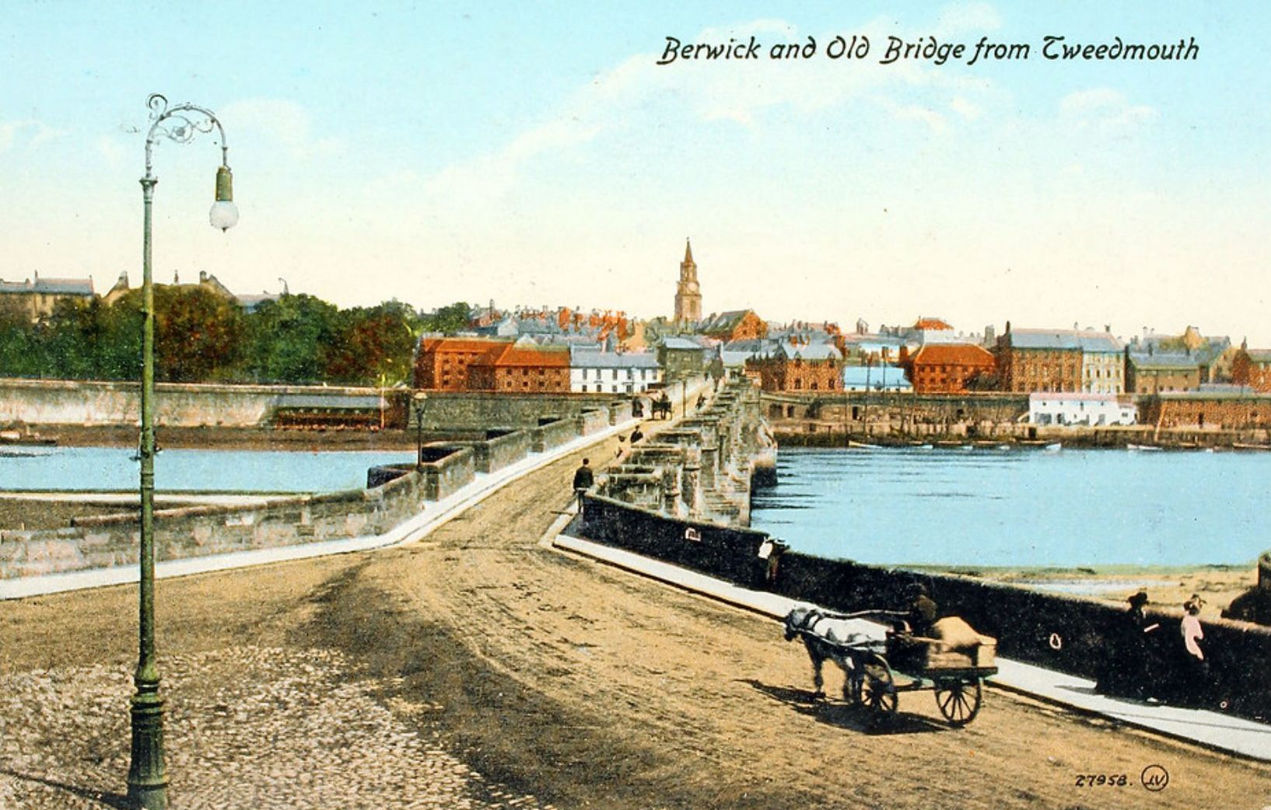
Early twentieth-century view from Tweedmouth over the Old Bridge towards Berwick
The view in 2025 shows mainly low-lying, historic buildings, marred only by the Sports Direct building whose saving grace is not being extensive in its width and mass, and therefore not distracting the eye from the other more substantial buildings in its proximity.
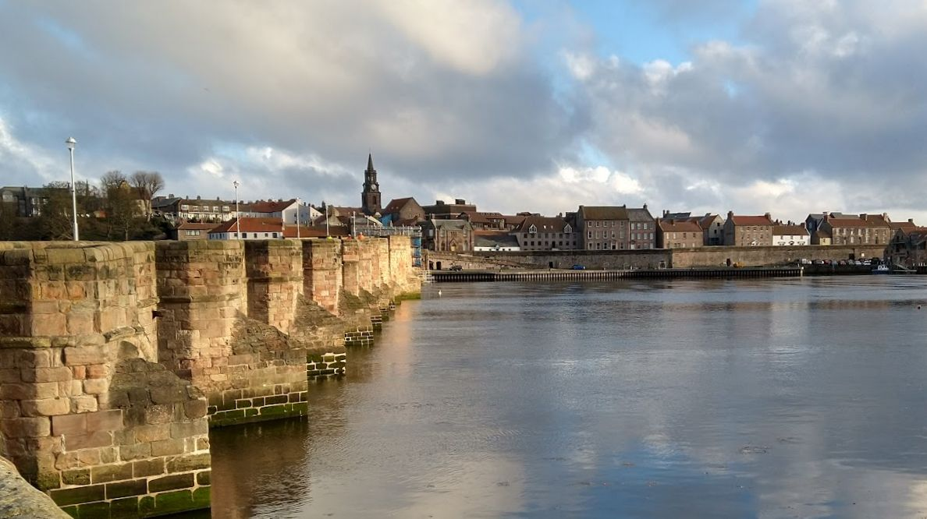
2025 view from Tweedmouth over the Old Bridge
In contrast, the new Maltings, both tall and wide, would dominate that view (below), destroying the historic character that is so essential to Berwick while still revealing the Sports Direct building from various angles. Indeed, it combines with that building to produce an even larger, unbroken mass of modernity intruding on the setting.
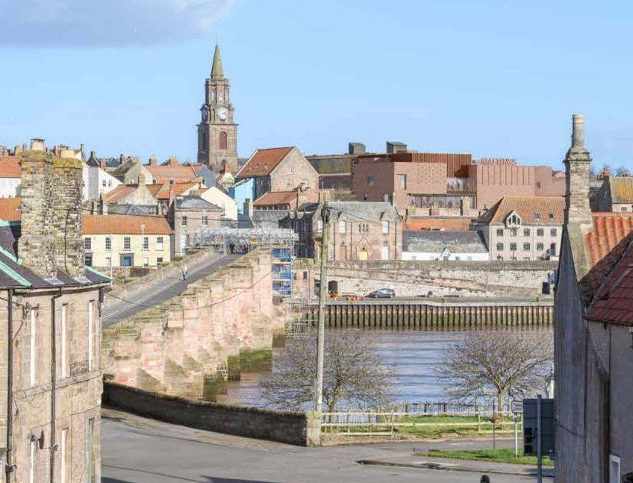
Proposed view across the Old Bridge towards Berwick
It will become harder to market Berwick as an ‘unspoilt’ historic market town when the truth is that it will have been spoilt. It is likely to set a precedent for further damaging buildings and signage, causing more harm to the town’s appeal.
As one owner of a holiday let said in her objection:
“The preservation of the town’s beautiful historic character is crucial not only for its heritage but also for the well-being of its residents and the livelihoods of businesses like mine that rely on tourism.”

7.3. Bird nuisance
The flat roof design will exacerbate bird problems within the town. The problem can be observed from the Ramparts near the hospital, looking towards the roof of the B&M store, and it will place an ongoing burden on the taxpayer.
Any mitigation is likely to be unsightly (for example, see the nets on the flat roof areas of Morrisons), and add to the harm to the historic roofscape, amplifying the consequences of the heritage damage the building will already do.
Seagulls carry diseases, and an increase in their droppings in the centre of town may impact local quality of life and tourism.
The lack of specificity in the application about how the problem will be managed is an important omission and raises concerns about the practicality of the proposed design in day-to-day use.

7.4. Harm: the wellbeing of locals and visitors
In damaging its setting and the conservation area, added to the potential increase in bird nuisance, the planned building is likely to harm the wellbeing of the town’s residents and visitors, and impact the tourist industry. In the case of the damaged aesthetics of the town, this is continual, ongoing harm that cannot be mitigated, neither to reduce the psychological impact of living with such heritage damage nor restore the reputation of the town as a heritage lure for tourists.

8. Procedural and Transparency Failures

8.1 Introduction
For such an expensive taxpayer-funded project, there has been a worrisome lack of transparency in the whole commissioning process, from as far back as 2019. Here we look at some of them.

8.2 Refusal to show the feasibility study
In 2019-20 the Maltings Trust spent £121,274 on a ‘feasibility and scoping study’ for an ambitious capital project to redevelop the site. Money was given by the Borderlands Partnership for this important study. One can presume it made the detailed business case for the much touted “cultural regeneration” and crucially, why the existing building could not be refurbished without a major rebuild. This study is often quoted as “establishing the preferred approach” as a result of the existing Maltings being “not fit for purpose.” This was clearly an important foundational study as the idea of building being “not fit for purpose” is often repeated to justify everything about the new plan.
For example, a building tender document posted by NCC on the Bidstat website in July 2024 states:
“The existing Maltings venue is ageing, no longer fit for purpose, fails to exploit its unique river-view location, and presents ever-increasing operational challenges – e.g., tired furnishing and décor, lack of soundproofing which prevents simultaneous programming, inaccessible areas for audiences and artists with disabilities, seating and facilities which fall far short of modern audience expectations, antiquated heating, wiring and ventilation. An independent scoping and feasibility study has clearly established the preferred approach – delivering a 21st century venue (the New Maltings) on the existing site that transforms both the customer experience and business model and acts as a major catalyst for the regeneration of Berwick-upon-Tweed.”
However, despite repeated requests, The Maltings Trust, NCC and Advance Northumberland have refused to release this critical study to the public. Ros Lamont, CEO of the Maltings, said that the findings of the study are all laid out in the planning proposal documents. However that is far from the case. We are left imagining what it might have contained. How is is possible for the public to make a fair assessment of the merits of this proposal when we are not allowed to see the arguments that caused it to be made in the first place?

8.3 Secretive competition
In March 2021, after the £17.7m redevelopment plan was announced for the Maltings, with £15m from the Borderlands Regeneration Deal and the rest contributed by Northumberland County Council, an architectural competition to select a design and an architect was launched under the auspices of the Royal Institute for British Architecture (RIBA).
An architectural brief was published to guide submissions. It states:
“This project will provide a landmark building and high-profile visual symbol of the impact of the Borderlands Inclusive Growth Deal. The new Maltings will also act as a key driver for the culture-led regeneration of Berwick-upon-Tweed — and a significant catalyst for economic growth, job creation, renewed civic pride, destination tourism, creative and commercial development.”
Also stated was an aspiration for the building to be
“an architectural beacon overlooking the River Tweed and visible from the Royal Border railway bridge and East Coat Mainline train route” (taken from the Maltings web site).
So an explicit goal was to be highly visible, with the implication that this would override all other aesthetic considerations and be a flag-waving opportunity for the Borderlands Inclusive Growth Deal initiative.
An evaluation committee was formed to judge the competition. How the make-up of this judging committee was determined is not known.
It consisted of:
- Ros Lamont Executive Director, The Maltings (Berwick) Trust
- Megan Mullarkey/Conlan Project Manager, Advance Northumberland
- Euan Macdonald, RIBA Architect Adviser & Partner Hawkins\Brown
- Andrew Mowbray, Head of Project Management Advance Northumberland
- Damon Barnaby, Project Manager Northumberland County Council
No elected representatives were appointed to the committee, nor any members of heritage organisations, for example Historic England.
No further information is available to the public about how the judges were chosen or how the shortlist of firms was determined. This latter matter soon became controversial when the current president of RIBA Simon Alford’s own architectural firm, AHMM, was put on the shortlist.
Experienced competition organiser Malcolm Reading of Malcolm Reading Consultants said in the Architect’s Journal:
“This situation is a classic conflict of interest issue and organisations should have policies in place to manage this. It should never have happened. Fixing it is easy. AHMM should withdraw, the RIBA should apologise to the client for poor governance and wasting time, and then put policies in place to prevent a recurrence.”
AHMM did not withdraw.
Reading also questioned the make-up of the final five. He asked:
“Why is the shortlist made up of well-established firms? It’s a modest project yet would be perfect for smaller practices and new talent.”
The shortlist was formed of the following firms:
- Allford Hall Monaghan Morris (AHMM)
- Burrell Foley Fischer
- Carmody Groarke
- MICA Architects
- Space Architects
All these are large, London firms with wide experience in the cultural sector, some particularly noted for theatre work. They are all also ardent modernists. This is not, of course, unusual in the world of architecture today. Firms that take any other line are seen by many as radical outliers. However, there are notable practices who might have been shortlisted, for example ADAM Architecture, Porphyrios Associates, Francis Terry and Associates, Ben Pentreath Ltd, or Craig Hamilton Architects. These firms excel in delivering historically informed, context-sensitive designs that resonate with clients seeking timelessness and craftsmanship. Their influence is amplified by awards, policy contributions, and high-profile projects, from private estates to urban masterplans like Poundbury. Neither do any smaller firms from the North East seem to have been considered, nor as noted above, newer practices. The Ad Gefrin project, which also received Borderlands funding, used a local architect to great effect, producing a building that reflects Northumbrian tradition while supplying modern facilities.
In March 2022, Historic England sent the Maltings and/or NCC a letter strongly advising the removal of the goal to create a “landmark beacon” from the architectural brief, and urges the chosen architect to work within the character and context of the town. This letter is quoted in Appendix A.
In January 2024 architects MICA were appointed. They released a statement and an image of a possible interior which might be described as generic. The competing design proposals were not made public.
In March 2024 MICA were awarded a £2,180,426.67 contract, roughly 10 percent of the proposed cost.
This all flies in the face of conventional practice. Architectural competitions are typically structured to ensure transparency, fairness, and diversity in design outcomes, but the Maltings redevelopment competition appears to have deviated from these norms, fostering perceptions of secrecy and exclusivity.
Competitions are usually overseen by a professional body such as RIBA, or an independent organizer like Malcolm Reading Consultants, with explicit guidelines on jury composition, eligibility, and evaluation criteria published upfront. The jury typically includes a mix of architects, local stakeholders, elected officials, heritage experts, and community representatives to balance technical expertise with local context.
For example, the 2016 competition for the Tintagel Castle Footbridge, organized by Malcolm Reading Consultants for English Heritage, had a jury comprising architects, engineers, local council representatives, and heritage experts. The process was transparent, with public announcements detailing the jury’s composition and selection criteria.
Shortlists are formed through a clear process, often involving a call for expressions of interest or portfolios, evaluated against published criteria, such as experience, design philosophy, or project scale.
Smaller or regional firms are often encouraged to participate, especially for projects tied to local regeneration, to foster inclusivity and context-sensitive designs. The 2019 competition for the Preston Bus Station refurbishment included a mix of established firms and smaller regional practices, with the shortlist announced publicly alongside justifications for each firm’s inclusion.
Competing designs, even if not selected, are typically shared to demonstrate the range of ideas considered, enhancing public trust. The 2002 competition for the Scottish Parliament building, managed by RIBA, included public exhibitions of shortlisted designs across Scotland, with feedback incorporated into the final evaluation. The winning design by Enric Miralles was announced with detailed jury reports.
Strict policies prevent conflicts of interest, such as barring jury members or competition organizers from participating. If a conflict arises, firms are expected to withdraw, or the individual recuses themselves. In the 2017 Sydney Modern Project competition, the Art Gallery of New South Wales ensured no jury member had ties to shortlisted firms, and RIBA’s code of conduct was explicitly followed to maintain impartiality.
The Maltings competition diverged significantly from these standards, fostering perceptions of secrecy and exclusivity.
The lack of clarity on how the evaluation committee was formed – consisting of Maltings Trust, Northumberland County Council, Advance Northumberland representatives, and one RIBA architect adviser – raises concerns about impartiality. The absence of elected officials or heritage experts (for example Historic England) limited representation of local or contextual interests. Unlike the Tintagel Castle competition, where jury members were publicly named with their qualifications, the Maltings process provided no public justification for the committee’s makeup, fuelling speculation about insider influence.
Furthermore, the inclusion on the shortlist of AHMM, led by RIBA president Simon Allford, was a glaring conflict, as noted by Malcolm Reading. Standard practice would have required AHMM’s withdrawal or Allford’s recusal from RIBA’s oversight role.
The shortlist comprised only large, London-based modernist firms excluding smaller regional practices, emerging talent, or firms with classical or context-sensitive approaches such as ADAM Architecture and Porphyrios Associates. This homogeneity limited design diversity and ignored Berwick’s historic character.
The competing design proposals were not made public, unlike standard practice where shortlisted designs are exhibited to engage the community. This secrecy prevented Berwick’s residents from understanding the range of visions considered or providing input.
Historic England’s 2022 letter urging the removal of the “landmark beacon” goal and emphasizing contextual design was seemingly sidelined, as MICA’s appointment and generic interior image suggest a modernist approach prevailed. This contrasts with competitions like Tintagel, where heritage considerations were central to the brief and jury deliberations.
Architectural competitions thrive on transparency, diversity, and public trust, as exemplified by well-documented cases like Tintagel or the Scottish Parliament. The Maltings competition, however, operated with notable secrecy, from its unclear jury formation to its refusal to disclose designs or address conflicts of interest. This approach not only risked alienating the community but also limited the project’s potential to deliver a design that truly resonates with Berwick’s cultural and historic fabric.

8.4 Inadequate visualisations
The full planning proposals were first published in March 2025 and contained over 99 documents for the public to digest. One of the most significant and revealing documents presented in this kind of planning application is the Design and Access Statement. In the case of the Maltings these formed two large PDFs charting the design process and the eventual proposal. One of the most crucial parts of the second volume is a series of side-by-side photographs, taken from various standpoints in the town, showing what the impact of the building will be on the views (see Appendix B).
While most of these images did not spare the viewers’ feelings as to the impact the proposed redevelopment would have on familiar views, for example at points from the Quay Walls and along the Sally Port, it was less obvious in some of the other images. On closer examination it seemed that the building would not be visible from Meg’s Mount, Dock Road and Sandstell Road Car Park.
After some head scratching, we realised that the Design and Access Statement had omitted to show suitably modified views: image pairs were identical in these three instances. On pointing this out to the planning officer, they were asked to submit new images containing the visualisations. They did, and they were uploaded as high resolution files. However, this did not improve matters. The images did not show a fully rendered new building but a red framed outline that does not give a clear idea of the impact of what is proposed. Even when the PDF is zoomed in to 500%, the red outlines are barely visible, and the scale at which the new Maltings will be viewed is completely different in real life than the very wide-shot, distant photographs.
Below, you can see how their Dock Road visualisation appears in their updated, supposedly high-resolution PDF. It is not really possible to see the new Maltings ‘visualisation’ at this scale.
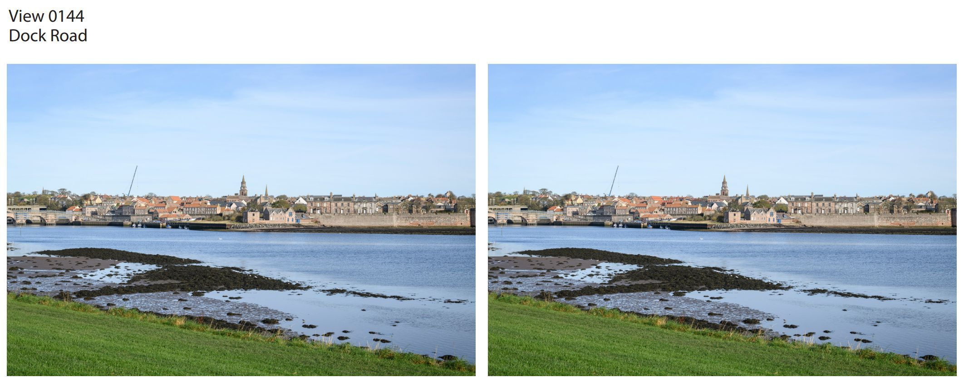
Updated view from Dock Road with barely visible red outline
By scaling the PDF to 500%, as seen in the image below, you can just make out the red outline.
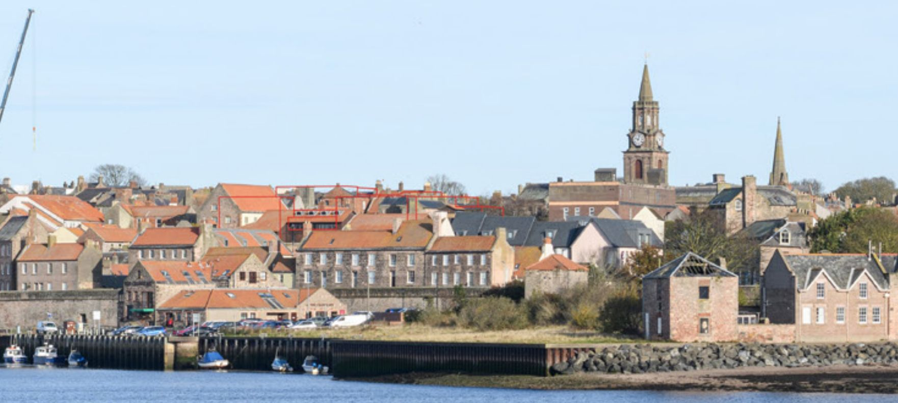
Part of the same PDF zoomed in 500%, with faint red outline just visible
The following image was taken by us from Tweedmouth Town Green on Dock Road, a little to the west of the Design and Access Statement’s photograph. It has been ‘calibrated’ to represent as closely as possible what you would see on a typical smartphone screen when taking a picture that is at the same scale as what you see over the top of the phone. That is, it’s a much more realistic view from Dock Road – one which shows that the top of the existing Maltings, and Sports Direct building, are clearly visible.
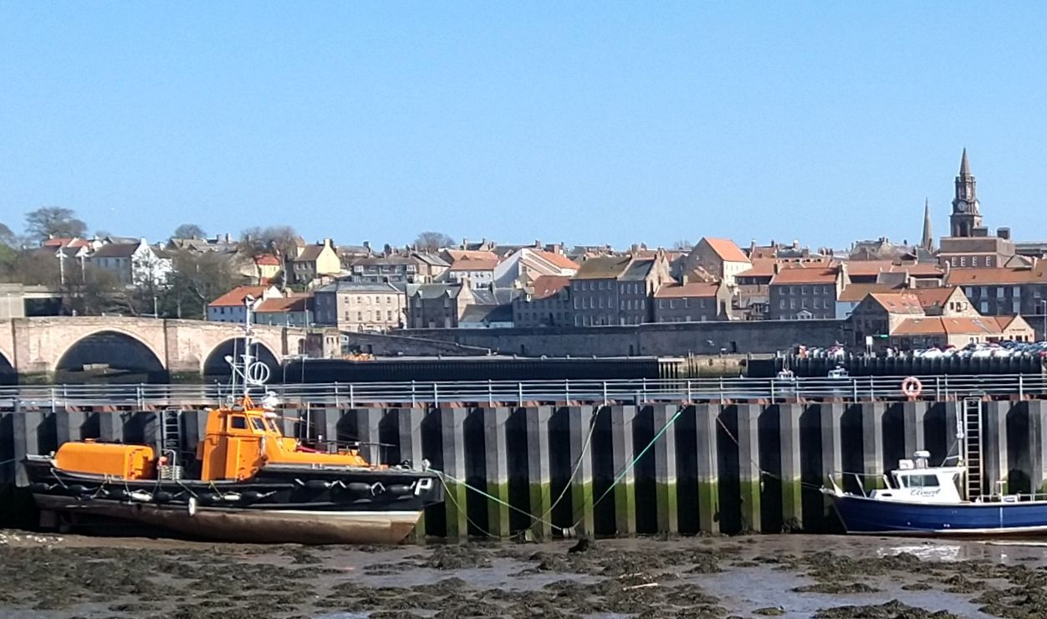
What you will see from Dock Road on a phone screen at the same scale as reality
That these shoddy official visualisations are considered acceptable when making the case that there will be scarcely any damage to much loved views of a conservation area is surprising to say the least, and calls into question the legitimacy of the planning consultation process.

8.5 Harm: public confidence undermined
Given that this is a taxpayer-funded development, transparency is particularly important. But at many critical points, there has been a lack of meaningful public engagement and accountability as discussed in Chapter 3. This has been compounded by a refusal to clarify the necessity for such a large redevelopment, the secretive architectural competition and the inadequate visualisations presented as part as the planning application – itself a behemoth that is designed to bewilder the ordinary observer into mute submission. Berwick and its residents deserve better than this.

9. Conclusion: A Call to Protect Berwick
The proposed redevelopment of the Maltings Theatre in Berwick-upon-Tweed, while ambitiously marketed as a catalyst for cultural and economic regeneration, is a fundamentally flawed initiative that threatens the town’s historic character, community cohesion, and long-term sustainability. This analysis has exposed critical shortcomings across multiple dimensions: the proposal’s disregard for Berwick’s cherished heritage, inadequate community engagement, overstated economic and social benefits, environmental deficiencies, accessibility challenges, vulnerability to external risks, and procedural opacity. Together, these flaws paint a picture of a project driven by external funding pressures and modernist ambitions rather than a genuine commitment to Berwick’s unique identity and needs.
Berwick deserves a cultural venue that enhances, rather than undermines, its historic legacy and community spirit. We call on Northumberland County Council, the Maltings Trust, and decision-makers to reject this flawed proposal and pursue a context-sensitive alternative that respects Berwick’s heritage, engages its residents meaningfully, and delivers sustainable benefits.
Protecting Berwick’s soul – its intricate townscape, vibrant community, and timeless appeal – must take precedence over a misguided vision that prioritises visibility over harmony. Let us act now to safeguard Berwick for future generations.

Appendix A: Maltings Timeline
This timeline notes significant events in 31 years of the Maltings, from 1984 to 2025.
1984
Fire destroys much of the derelict early-19th century Maltings, which had been purchased by Berwick Borough Council for housing. Three boys are arrested.
1988
The charity ‘Maltings (Berwick) Trust’ is formed.
1990
After a public campaign to build a professional arts centre in Berwick, the Maltings venue in Eastern Lane is opened. Designed by Graham Law and Colin Ross of architects Law and Dunbar-Nasmith, the new building sits well in its context, without overpowering the skyline and its terracotta roofs melding with the historic architecture of the town.
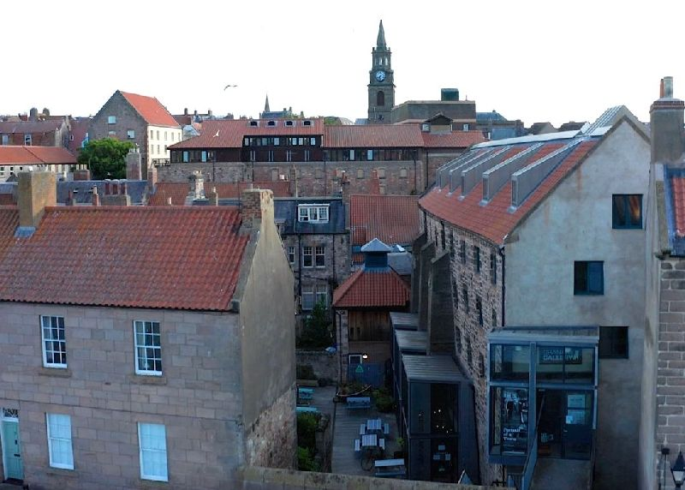
The 1990 Berwick Maltings from the Quay Walls
1991
The Maltings building wins a RIBA Regional Award. On 22nd November 1991, The Newcastle Journal states:
“At the Maltings in Berwick, the Law and Dunbar-Nasmith Partnership designed an arts centre within a building which had been a multi-storey maltings and grain store. The opportunity was taken to use this centrally located site to provide a 330-seat theatre with fully equipped stage. The judges said: ‘This is a scheme of great imagination and positive conservation.’”
2011
The Henry Travers Studio was updated and improved, creating an additional theatre space transforming it into a “state-of-the-art black box studio theatre” with retractable seating for 74.
2014
Elected council leaders form a group to co-operate for the good of the historic Borderland region and lobby central government for regeneration money.
“The Partnership is a coalition of five councils representing Cumberland, Dumfries and Galloway, Northumberland, Scottish Borders and Westmorland and Furness. The first Borderlands summit was held in April 2014 in Peebles where regional leaders met for the first time to discuss shared economic opportunities and challenges. These included areas including tourism, energy, forestry, education and training.
The authorities continued to work in partnership and in 2017 the Borderlands Inclusive Growth Proposition was submitted to both the UK and Scottish Governments. After years of further development work the Borderlands Inclusive Growth Deal was signed in March 2021 bringing up to £452 million of fresh investment to the Borderlands area. The Partnership make up changed following Local Government Reorganisation in April 2023 with Cumberland Council and Westmorland and Furness Council replacing the former Carlisle City Council and Cumbria County Council.”
(From www.borderlandsgrowth.com/the-partnership)
2016
Northumberland County Council commissions a report into the condition of the building.
2017
A Berwick-upon-Tweed Economic Plan is published. The refurbishment and expansion of the Maltings is suggested as a goal, at a cost of £250,000. This would allow for 350 more performances a year.
2019
Borderlands partnership secures the first large funding commitment. The Berwick Conference Centre and Theatre is stressed as a priority.
“To support the visitor economy and local growth in the town, UK Government will invest in Berwick Theatre and Conference Centre to facilitate culture led regeneration and economic development in the area.”
(From https://assets.publishing.service.gov.uk/media/5d28a5fb40f0b64a8099e167/Borderlands_Growth_Deal_-_Heads_of_Terms_2019.pdf)
The Maltings Trust then spends £121,274 on a ‘feasibility and scoping study’ for an ambitious capital project. Money was given by the Borderlands Partnership. The Maltings Trust, NCC and Advance Northumberland are all refusing to show the outputs of this study to the public.
March, 2021
Based on the feasibility study, a £17.7m redevelopment plan is announced for the Maltings, with £15m from the Borderlands Regeneration Deal and the rest contributed by Northumberland County Council.
An architectural competition to select a design and an architect is launched under the auspices of the Royal Institute for British Architecture (RIBA).
An architectural brief is published to guide submissions. It states:
“This project will provide a landmark building and high-profile visual symbol of the impact of the Borderlands Inclusive Growth Deal. The new Maltings will also act as a key driver for the culture-led regeneration of Berwick-upon-Tweed – and a significant catalyst for economic growth, job creation, renewed civic pride, destination tourism, creative and commercial development.”
Also stated was an aspiration for the building to be “an architectural beacon overlooking the River Tweed and visible from the Royal Border railway bridge and East Coat Mainline train route” (taken from the Maltings web site).
So an explicit goal was to be highly visible, with the implication that this would override all other aesthetic considerations and be a flag-waving opportunity for the funders of the Borderlands initiative.
An evaluation committee is formed to judge the competition. How the make-up of this judging committee was determined is not known. It consists of:
Ros Lamont Executive Director, The Maltings (Berwick) Trust
Megan Mullarkey/Conlan Project Manager, Advance Northumberland
Euan Macdonald, RIBA Architect Adviser & Partner Hawkins\Brown
Andrew Mowbray, Head of Project Management Advance Northumberland
Damon Barnaby, Project Manager Northumberland County Council
No elected representatives were appointed to the committee, nor any members of heritage organisations.
21st March, 2022
The new Maltings design becomes controversial when the president of RIBA Simon Alford’s own architectural firm, AHMM, is shortlisted.
Experienced competition organiser Malcolm Reading of Malcolm Reading Consultants said:
“This situation is a classic conflict of interest issue and organisations should have policies in place to manage this. It should never have happened. Fixing it is easy. AHMM should withdraw, the RIBA should apologise to the client for poor governance and wasting time, and then put policies in place to prevent a recurrence.”
AHMM did not withdraw.
Reading also questioned the make-up of the final five and asked:
“Why is the shortlist made up of well-established firms? It’s a modest project yet would be perfect for smaller practices and new talent.”
24th March, 2022
Historic England send the Maltings and/or NCC a letter advising removing the goal to be a beacon visible from the train, and urge the chosen architect to work within the character and context of the town.
January, 2023
The architects MICA are appointed from a shortlist of five: Allford Hall Monaghan Morris (AHMM), Burrell Foley Fischer, Carmody Groarke, MICA Architects, Space Architects.
The competing design proposals are not made public.
February, 2023
Northumberland County Council asks for £5m more for Maltings Project from the Borderlands Fund. The cost of the proposed rebuild will now be over £22m.
March, 2023
MICA is awarded a £2,180,426.67 contract, roughly 10 percent of the proposed cost.
Apart from an interior image, the original winning design is not made public until the application is lodged in 2025. We do know that the very first design was L-shaped and lower than either of the later designs.
15th May, 2024
A Town Hall meeting is convened, with Maltings Trust chair Scott Sherrard presenting an update and taking questions. In response to our questions, he claimed that the goal of an “architectural beacon visible from the train” was the phrasing of the funding organisation (i.e. Borderlands), not the Maltings. He also assured us that the building would be “gorgeous”, and “not a shed”. Most remarkably, he claimed that the height of the building would not be higher than the existing 1990 building.
All of these claims would be contradicted in 2024 and 2025.
May, 2024
Northumberland County Council (the Maltings applicant) seeks a screening opinion (24/01683/SCREEN) from a planning consultant about the necessity of an Environmental Impact Assessment (EIA) in relation to the rebuild of the Maltings. From the consultant's letter:
“In light of these considerations, the intended application proposals do not exceed the relevant thresholds or meet the criteria in the Column 2 of Schedule 2, and as the site is also not wholly or partly in a sensitive area it follows that the proposal is not Schedule 2 development and that an EIA is not required.
I trust that you can agree with this analysis and duly provide formal written confirmation that there is no requirement for an EIA for the development that is proposed.”
The planning officer feel that it will not be necessary but notes:
“Berwick-upon-Tweed Conservation Area Character Appraisal suggests that the existing Maltings building is regarded to have certain merits in terms of how its design echoes traditional local features, such as roof vents and the use of pantiles. Whilst no information has been submitted at this stage, keeping the scale and massing of the proposed extensions in proportion with the surroundings would likely mean that any impacts arising would be limited.
The site is located within the Berwick Conservation Area and within the setting of a number of listed buildings. There is potential for the proposed development to have an impact on existing heritage assets, including potentially having a significant effect on the archaeological assets and cultural heritage of the site area. Keeping the scale and massing of the proposed extensions in proportion with the surroundings would likely mean that any impacts arising would be limited and opportunities should be taken to ensure the development preserves or enhances the surrounding heritage assets.”
Although given the knowledge at the time (no sight of the plans!) the planning officer considers there to be no requirement for an EIA, he cautions:
“The LPA (local planning authority) reserves the right to alter this screening opinion if further information becomes available to demonstrate that the environmental impacts of the proposal are likely to be significant in the terms specified in the Regulations.
This assessment does not imply any consideration of the planning merits of the proposals or indicate the likely success or otherwise of the application for planning permission.”
The EIA regulations include impact on cultural heritage and the landscape, and so given the impact on Berwick, this could be seen to be an attempt by the applicant to avoid due scrutiny. The planning officer acknowledges the potential for harm.
July, 2024
A brief public consultation of the proposed design is held. It takes the form of an exhibition at the Maltings which was open for a total of five hours, over two sessions on the 20th and 24th of July. The proposals were also made available in the form of a 6-page PDF which could be downloaded. People were invited to submit comments between August 2nd and August 19th. The building proposed had pitched roofs in places, as a small concession to the exceptional setting.
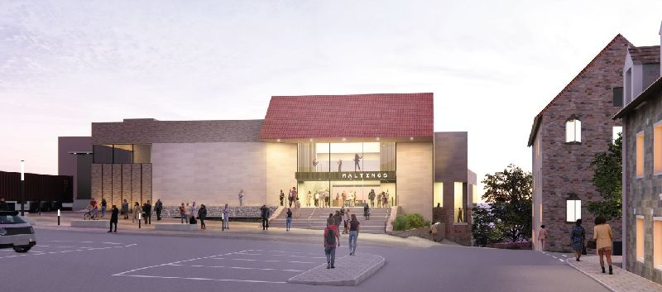
The rejected 2024 design: front elevation
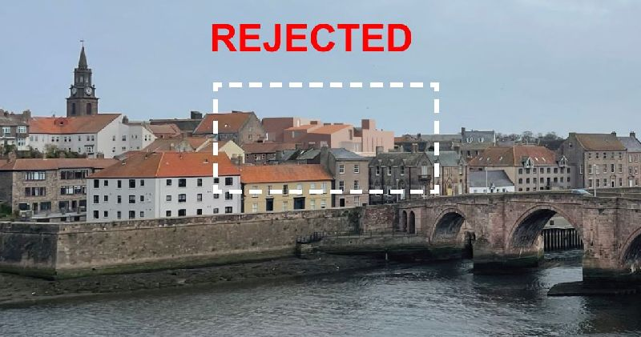
The rejected 2024 design: rear elevation
Historic England is brought in to consult on the suitability of the design. MICA is told to redesign the external appearance so as to appear less contrived and with flat roofs. The architect states that Historic England asked for “a building that looks modern” (a remark to Julian Smart during the second public consultation) and that the choice of a roof style was not his responsibility.
All county councils are required to devise and make public a Statement of Community Involvement. This includes consultation with local conservation groups and Historic England when applicable. Our opinion is that for this to be legitimate, local conservation groups have to be accountable to residents and take into account their opinions, especially on a plan that affects everyone.
Summer, 2024
Scott Sherrard, chairman of the Maltings Trust writes in the brochure covering the August to December 2024 season at The Maltings about the proposed redevelopment:
“Any design must live happily within its heritage location and the Berwick skyline, and we believe we can better exploit the panoramic views of that surrounding beauty.”
January, 2025
A second public consultation is held, again with limited hours (seven hours in total). The event takes place in the bar at the Maltings but is not signposted when viewers arrive at the event. Feedback forms are provided, but no pens or places to sit and write. The proposals are displayed on boards with very few exterior images. The impact of the building and the changes since the last public display are however still notable. It is described on the website as a ‘pre-planning consultation’. The 2024 and 2025 public consultations have now been available in physical form for a combined 12 hours.
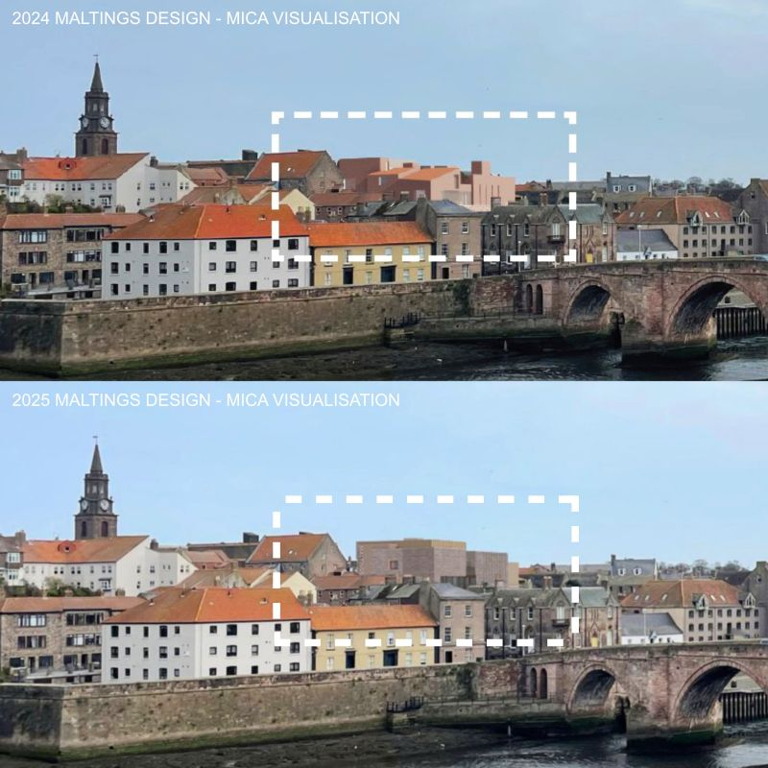
Comparison between 2024 and early 2025 designs
As shown in the comparison above, the roofline of the new design is even higher than the old one.
Public have until 7th February 2025 to make their feelings known, including online.
January, 2025
MICA makes a presentation to CAAG (Conservation Area Advisory Group) to which Julian Smart is kindly invited by CAAG’s chair. The extra visualisations shown are shocking in their impact on Berwick views. The architect suggests an electricity substation may be needed for the building. He also reiterates that they are not ideological about pitched or flat roofs but that Historic England (specifically, Martin Lowe) suggested pitched roofs would be ‘incongruous’. There is no mention of a huge flat-roofed building looking incongruous in its historic setting. Julian Smart requests that visualisations from the railway bridge be included (especially given the plant on the building's roof) as this is an important view and an introduction to Berwick for many. The architect says he will try to include this view (unfortunately there is no such visualisation in the application).
January, 2025
Our contact in Historic England is unable to give a satisfactory answer to the question of why they think the current design is sensitive to its location within Berwick (see berwick-heritage.co.uk/faq_maltings#historicengland for more details). We submit a Freedom of Information request to Historic England for the relevant correspondence where they advise the architect to remove the pitched roofs.
January, 2025
Berwick Heritage begins a campaign to change the design. A change.org petition is started to gather objections, and many people also make their feelings clearer on the feedback form for the second public consultation.
CAAG is expected to give their verdict on the plans shortly.
30th January, 2025
The Maltings put up a press release stating that the cost of the new Maltings is now £28.3m. The original cost was put at £17.7m.
14th February, 2025
Shortly after the second public Consultation, Scott Sherrard writes to the friends of the Maltings. In an email titled “The New Maltings: A beacon for a confident Berwick,” he states that the Trust will vacate the current building by May 31, 2025, with site clearance next, construction starting summer 2025, and a reopening slated for 2027. The new venue – backed by the Borderlands Partnership and Northumberland County Council (NCC) – promises a flexible theatre, two cinemas, community spaces, a river-view terrace, and an expanded café/bar, all to boost Berwick’s economy and confidence.
It defends the rebuild by citing the 2016 NCC condition report (millions in repairs needed) and the current building’s inefficiencies – skyrocketing energy costs, poor accessibility, and outdated facilities. Important changes include modernized spaces and a new Shoe Lane/Bridge Street entry, though details stay broad. The chair justifies the bold, modern design (by MICA Architects and Charcoalblue) as a necessary ‘beacon’ for a thriving Berwick, dismissing ‘pastiche’ (i.e. any other style but modernism) and embracing its boxy, assertive look despite its size and prominence.
Key phrases to justify the plan are “We believe Berwick’s cultural centre should not be afraid to stand out” and “a dramatic addition to views”.
Delays are blamed on scrutiny of public funds, inflation (e.g., Ukraine war steel costs), and site challenges like archaeology, with an £8m shortfall forcing redesigns. Economic perks – like the £500k Lowry exhibition uplift – are touted to sell the project, alongside jobs and community access. Q&As aim to address concerns, but the tone suggests a fait accompli, urging acceptance of a done deal over open debate.
The tone is quite different from earlier, more conciliatory statements such as “Any design must live happily within its heritage location and the Berwick skyline”.
18th February, 2025
The Northumberland Gazette posts an article “Planning application for the new Maltings venue in Berwick is imminent”. Council leader Glen Sanderson reveals that nearly a third of the 336 respondents reacted badly to the plan. The true figure is documented later as 37% against and 63% for.
19th February, 2025
Martin Lowe of Historic England responds to our question: how is the new design not incongruous in its setting? His reply reveals a disturbing lack of independence, starting from the assumption that the building must exist in this form, and the ideology of purist modernism (“form follows function”). The icing on the cake is citing the new hospital (already hated for its ugly intrusion into Berwick’s views) as a gleaming example of good design.
“Design is best considered in how it responds to its surroundings, both modern or historicist approaches can achieve this in theory. However, with large schemes such as the Maltings, or indeed the Infirmary a contemporary approach is better suited to dealing with a scale and requirements roof mounted plant machinery. In essence, the form better represents the function of the building, making for a better design.
As I understand the Maltings has been presented to the public on at least two occasions and whilst its design has changed it has always been a contemporary building. Considering the aspect from the south, this will make it noticeable within the traditional panorama of the estuary. Traditional reference is supplied by the brick and the way the building is broken up, rather than one monolithic block.
Adding further references such as roof slopes or traditionally sized window openings would produce a false looking building, possibly of a height greater than proposed and so more prominent. Furthermore, Berwick has styles of architecture across the centuries and modern buildings have a place in continuing that theme, particularly so public cultural buildings.”
This acceptance of untrammelled, ugly modernism in historic settings has destroyed the charm of many environments, in the UK and abroad. It’s sad to see it espoused by a body that is supposed to be protecting our historic settings.
24th February, 2025
In a letter to David Smith MP, the Berwick Civic Society planning committee endorses the latest Maltings design, singing its praises and excusing the flat roof on various pretexts. Mr Gowthorpe reveals that there is an informal advisory group to the Maltings, whose makeup has not been made public apart from his participation.
Mr Gowthorpe claims:
“Complex modern buildings generally require flat roofs to accommodate extensive mechanical and electrical plant, essential for energy efficiency, ventilation and temperature control. Much of this plant requires fresh air.”
And yet the previous design had a much more interesting roofline. We are told that it was Historic England that requested the flat roof out of the wish for a “modern design” – not that it was functionally necessary. Did MICA present a completely unworkable design in 2024? Surely such a large and experienced firm could not be so incompetent. So this has the flavour of a post-hoc justification.
Berwick Heritage strongly indicate to Mr Smith their views on the heritage destruction to be caused by the plan, despite all reassurances.
The Berwick Heritage petition reaches 336 signatures: the same number as the total number of respondents to the NCC survey.
3rd March 2025
Our Freedom of Information request to Historic England yields a letter written to the Maltings team in 2022, urging for restraint in the language used to call for a 'architectural beacon' in the brief. It mirrors our own concerns as expressed in the 2024 Town Hall meeting. The letter reads as follows:
“Dear (redacted)
The Maltings
Thanks very much for sharing the competition brief for the Maltings site in advance of our meeting. I think we need to be clear that, in addition to all its other benefits, this project represents a great opportunity for the heritage of the town. Clearance of buildings around the present Maltings has left quite a hole in the intricate and characterful townscape of Berwick. The opportunity exists then to stitch this area back together, both through the building itself and the public realm and other spaces around it, as well as delivering the centre envisaged.
We welcome the use of an architectural competition to stimulate creative responses to this space and excite a wider interest in the placemaking potential of the development. The competition brief also has lots of good things in it, and we particularly welcome the inclusion of the need for competition entries to respond to the historic context of the site and also avoid visual competition with the town hall.
My feeling is that the brief would be strengthened if it could avoid the use of the word landmark, and with it the desire to maximise views, and particularly the requirement for the building to be clearly visible from the railway bridge as an architectural beacon.
Our major concern is how the building would relate to the intricate townscape of the historic core of Berwick, and key buildings such as the town hall mentioned above. Several different approaches are available to this site which could produce a successful design. To us this is not about a need to avoid architecture with a strong visual identity, but it is about working within the historic character and context of the town. The aspirations for a landmark building and visibility from a distance could end up working against this context, so we would very much like to work positively with you to help develop an approach and design which avoids this. Thanks again for meeting us, and look forward to working with you.
All best wishes, (redacted)
Development Advice North East and Yorkshire – Regions Group”
4th March 2025
The application is submitted for validation.
12th March 2025
The application is made available to the public for viewing and comment: 25/00792/CCD. We begin our objection page with links and advice.
Mid 2025
A building contractor is expected to be chosen.
Late 2025
Building work is expected to commence.
2027
Expected completion of the building.

Appendix B: Visualisations
This is a selection of visualisations from the Design and Access Statement.
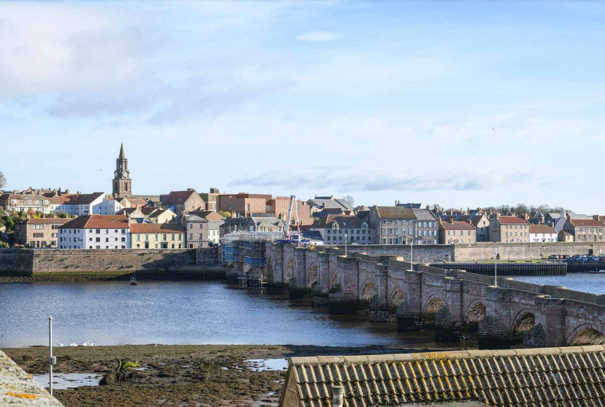
From the Royal Tweed Bridge (original)
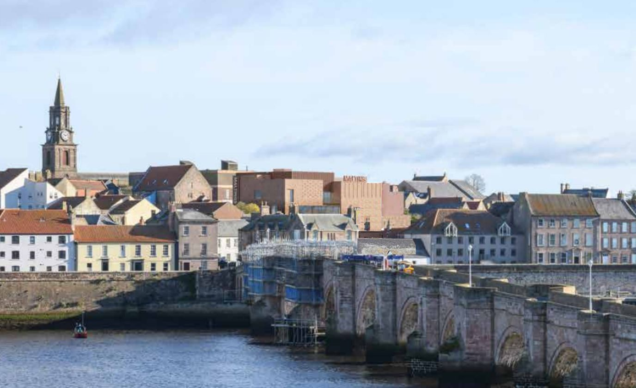
From the Royal Tweed Bridge (detail, crane removed by us)
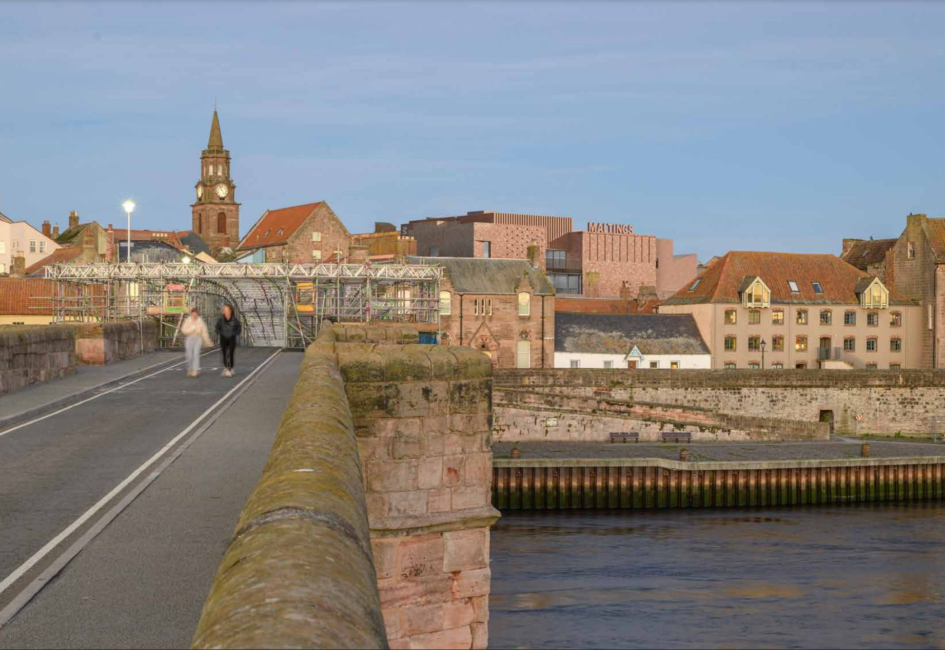
From the Old Bridge
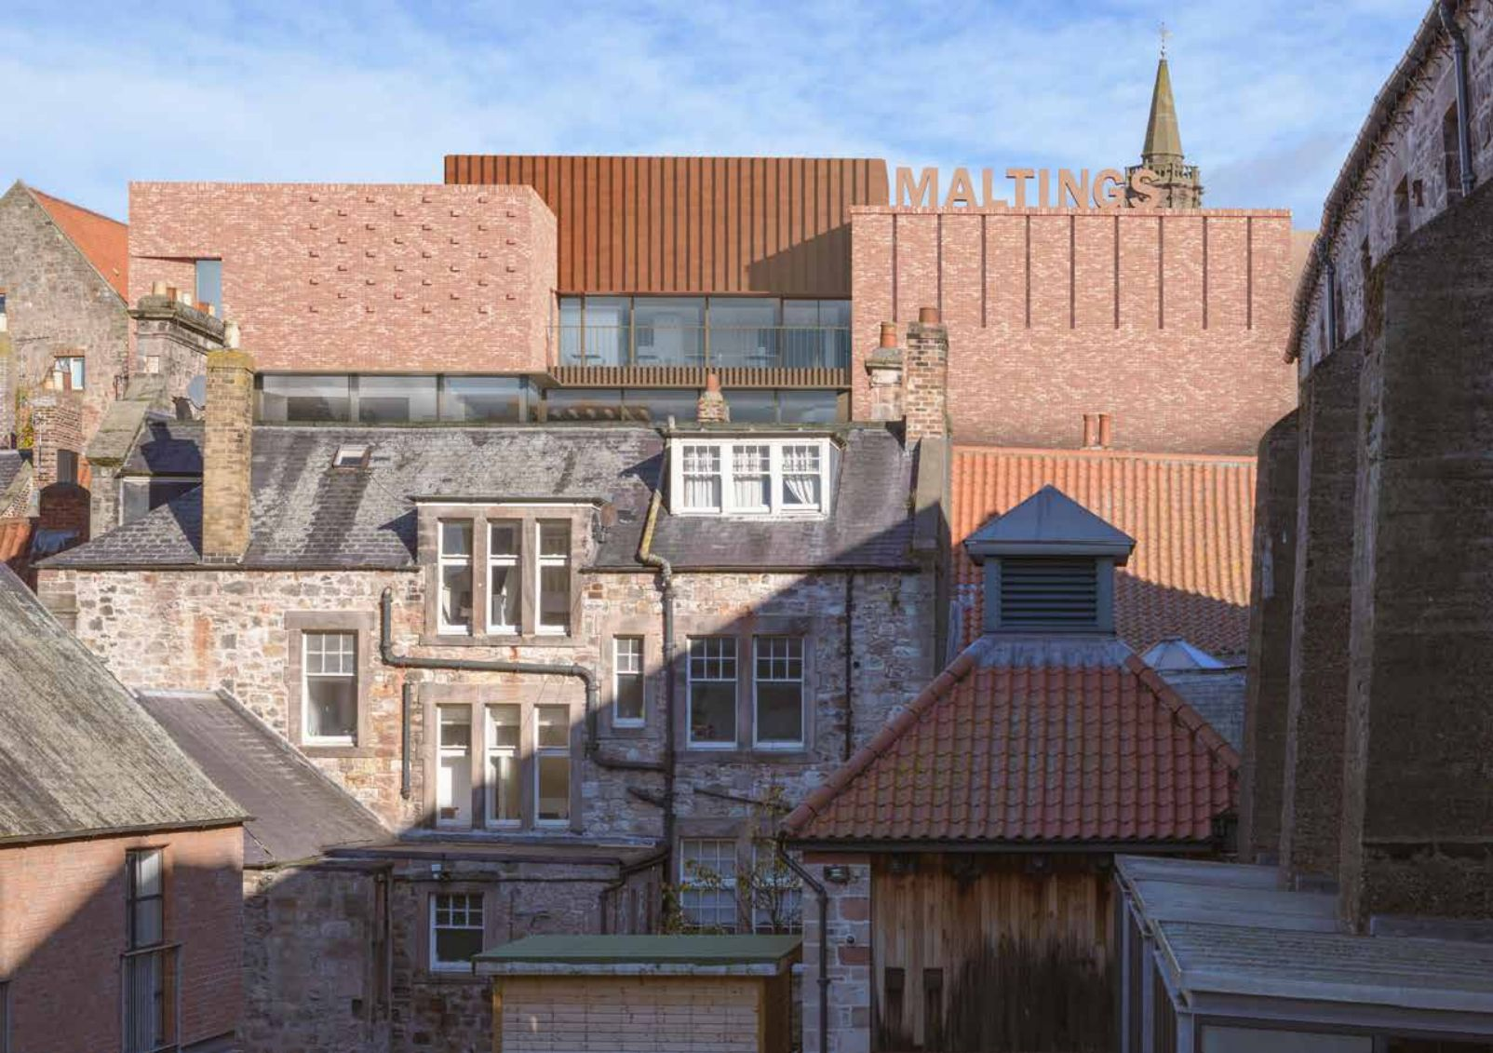
From the Quay Walls
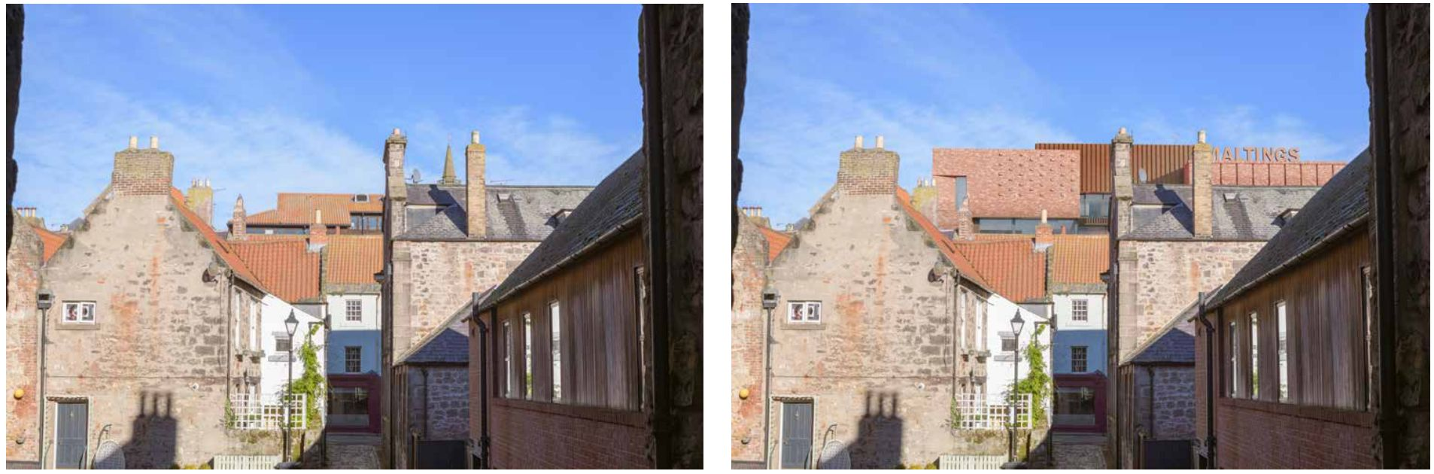
Across Sally Port, before and after comparison
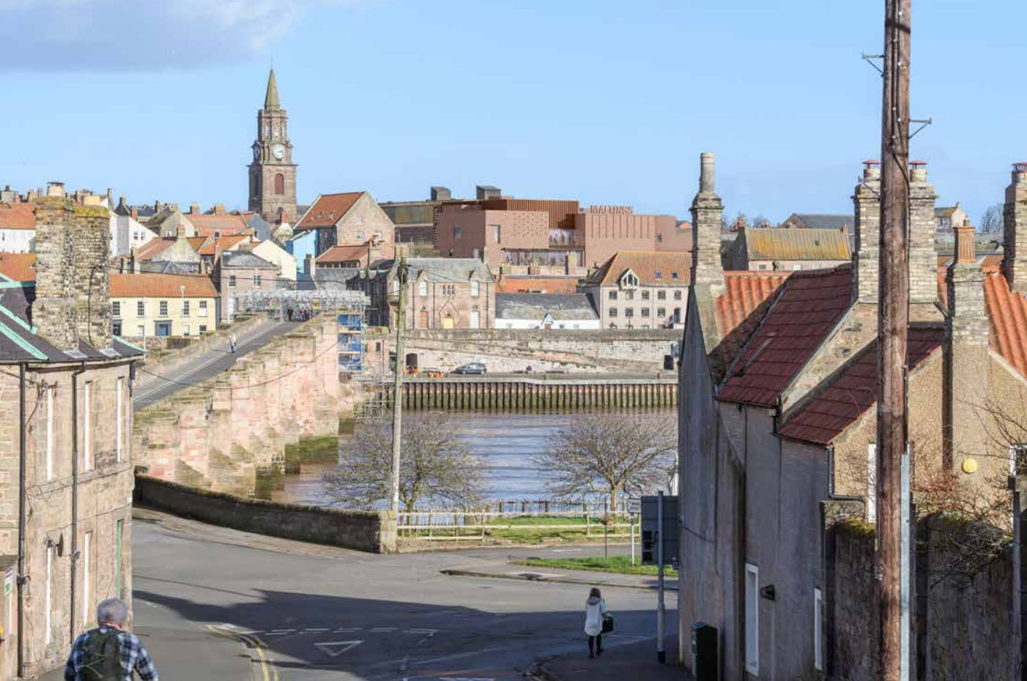
From Union Brae
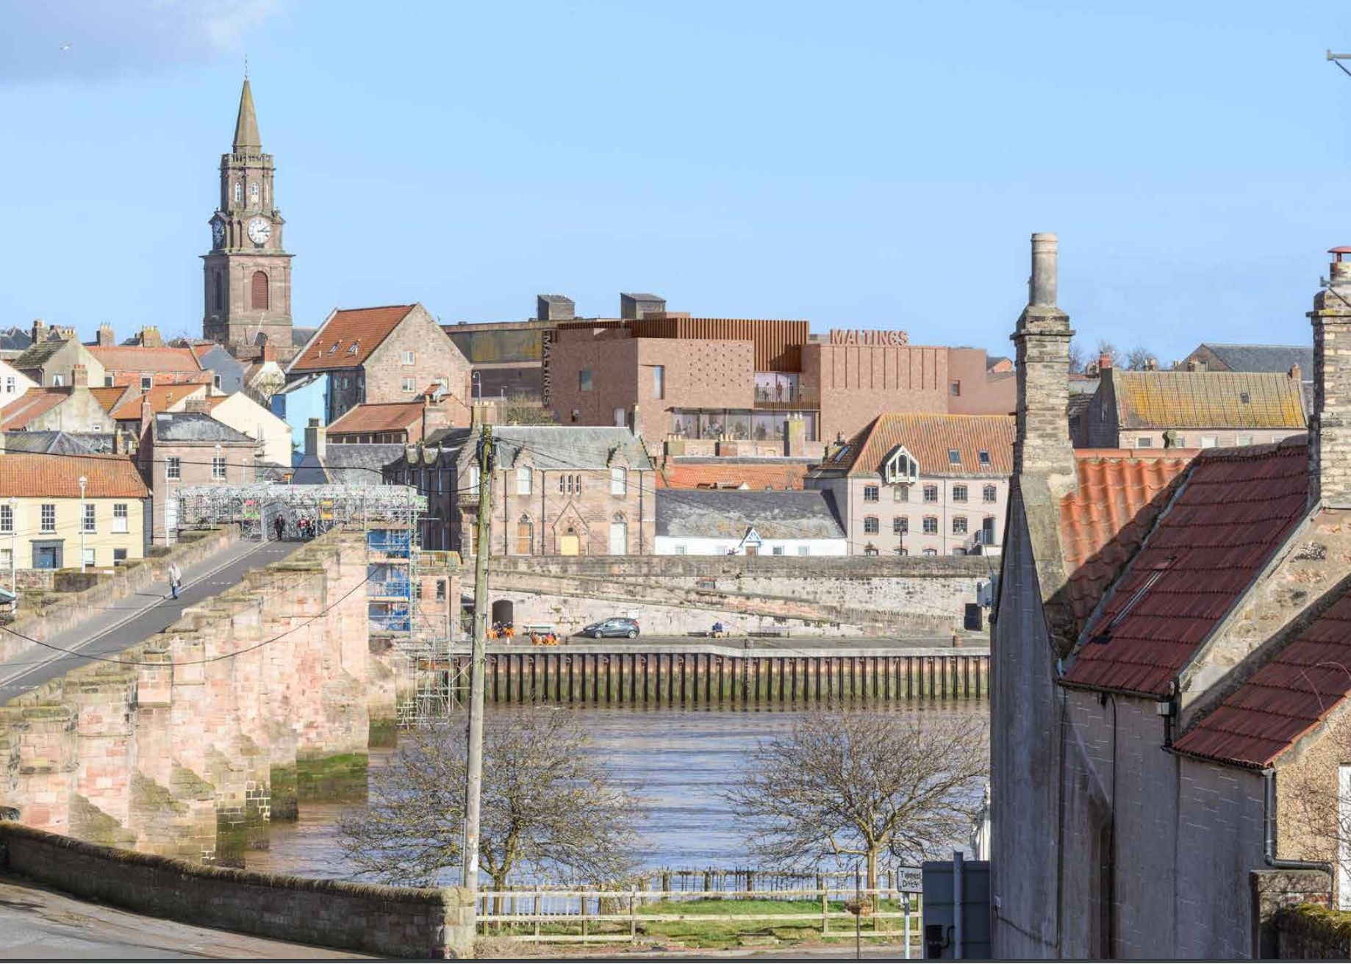
From Tweedmouth
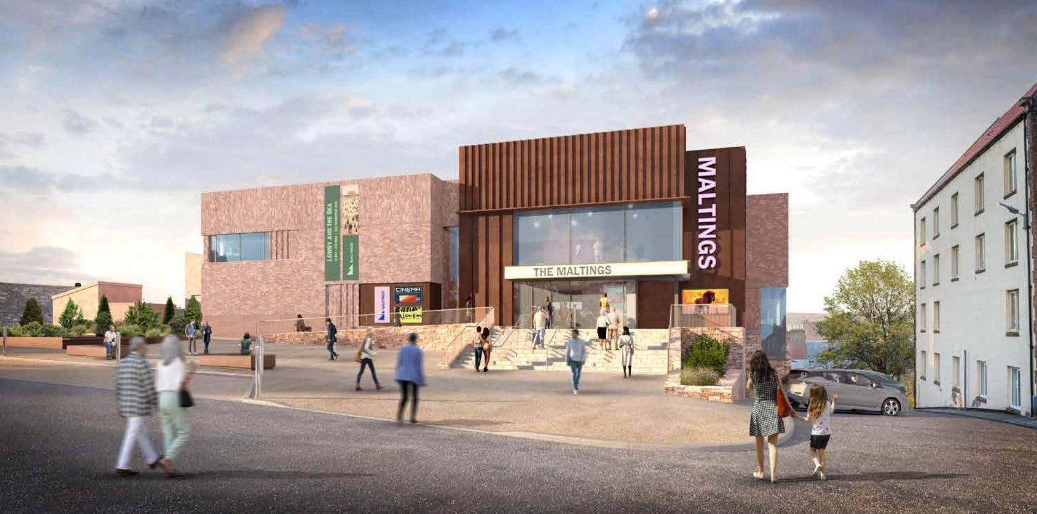
The front façade
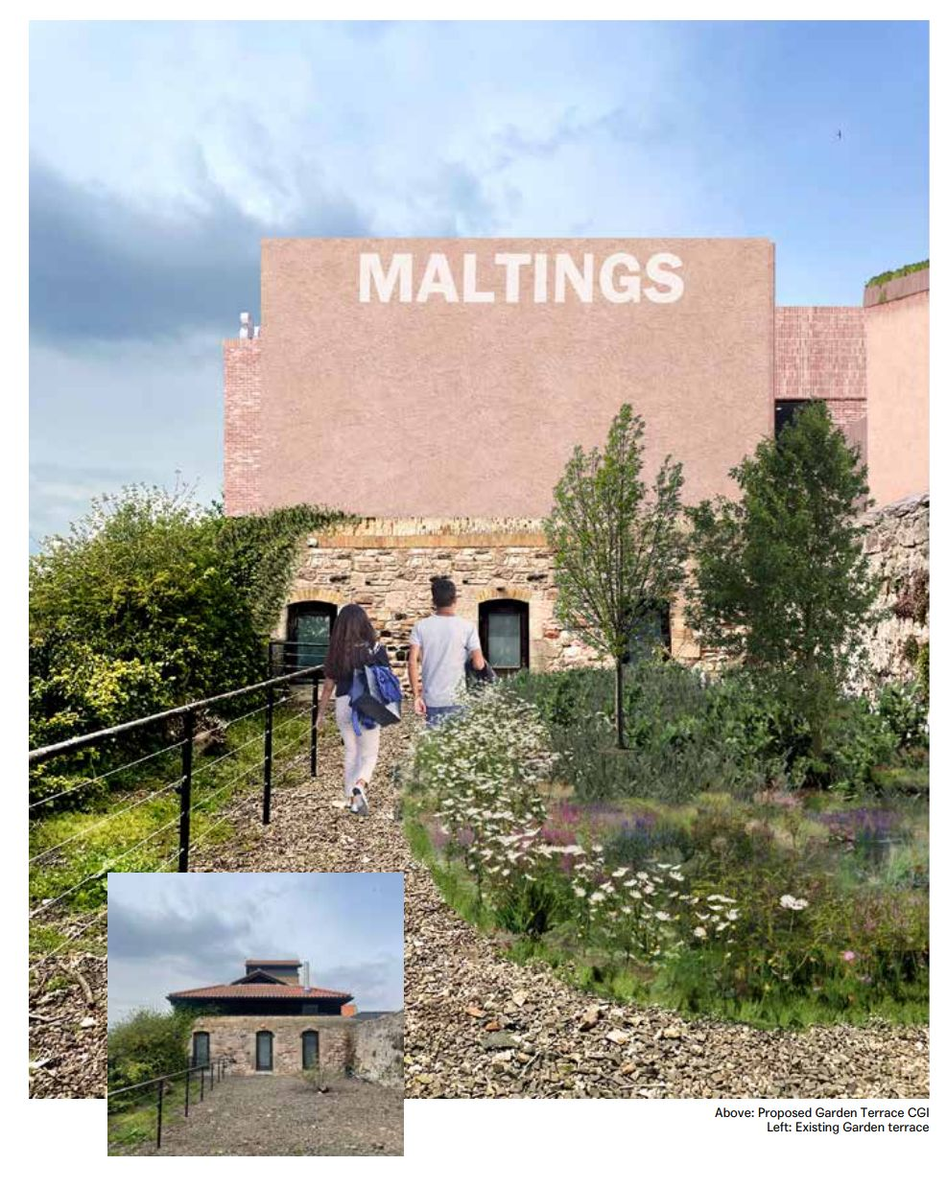
The Rain Garden (inset: before)
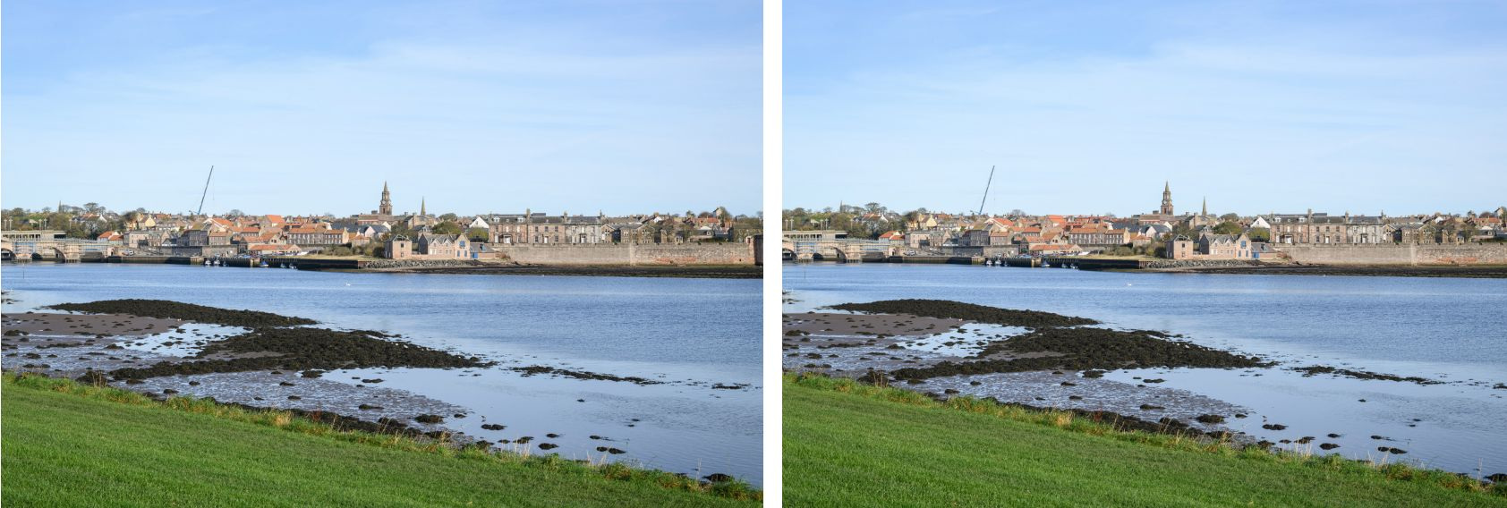
From Dock Road (unrealistically zoomed out, red outline hard to see)

Appendix C: Comments
Below we include a sample of comments made by people who signed the petition or responded on Facebook. You can also find more than 50 objections on the Northumberland County Council portal for application 25/00792/CCD (“Part demolition, alterations and extension to existing theatre and other ancillary works”).

A selection of petition comments
- “Please don't make the huge mistake of the 1960s by forcing "modern" architecture on an older town landscape. Time and again this happens and in my opinion ruins places. Please think again! Surely a good architect can be found to design a modern, functional building that sits beautifully amongst the surroundings? And while they are at it, adding some much needed greenery would soften any building.”
- “I live on the other side of the water and View the town daily. The new hospital is already an eye sore and a new Maltings development will create a skyline that is boxy and unwelcoming. Any design should fit with, and preserve, the historic character of the town.”
- “I am signing this petition because Berwick is not just a functional town, it is an historic town too and every effort should be made to maintain history of Berwick while we all have that the chance to do so. So many towns and historic sites are being ruined through what is called progress. The once lovely town York is drowned in what we call progress and you can't find the history of the place without it being pointed out. London, a city and very historic, but you wouldn't know that now. Let us keep Berwick as it should be and not spoil it with things we do not really need. Oh, yes we do need a theatre but not such a tall one. Such a blight to a quaint and lovely old town.”
- “Let’s get this right for Berwick. There is an earlier design with pitched roofs that felt so much more interesting. It looked a lot less ‘blocky’ and reminded me of a building depicted by Lowry. It felt much more in tune with the towns atmosphere. The new Maltings should be a modern building but it should hint at the fascinating history and stunning geography of Berwick please!!”
- “Good idea to expand the Maltings, however it does need to blend in with the surrounding buildings.”
- “Berwick is a unique, well-preserved historic town. This Maltings proposal is appalling and unthinkable.”

A selection of Facebook comments
- “Hell no. It’s an old town. Picturesque”
- “Looks nasty”
- “I think pets at home looks bad and that’s not in the town centre. This looks worse and in the middle of a historic town.”
- “I think a new modern arts building would be fantastic for the town but the architect should think outside the box and make the rear elevation something striking as well or something sympathetic to the current sky line.”
- “Less brutal dull cubes looking across the river into town.”
- “I would worry who would over see this makeover? We have all witnessed some very poor decisions both on practical issues and aesthetics over the past years. No accountability.”
- “I'm not against modern buildings per se but this is plain ugly. The youth project building's a great example of a newer but lovely building. It'll end up getting knocked down again in 30 years time, I suspect.”
- “Nooooooo can it not be a little more traditional.”
- “Oh no I hope not completely spoils the town view.”
- “It can look as modern as it wants but will it be ran the same way or stay stuck in its ways. If it doesn’t move with the times it will continue to scrape by. Even with a fancy pants makeover.”
- “Berwick has had many chances of regeneration in years gone by. New millennium bridge and quayside development, a marina - but councillors voted against and the marina went to Amble! Promote the Walls and get rid of some seagull shit would be a good start! Ultra modern makeover is not the way forward - old style and nostalgia is!”
- “I didn't realise that the existing building was going to be demolished and replaced, I thought it was just going to be an internal upgrade. Perhaps it would be better to start from scratch on a different site with better parking, etc. I'm not against improving the town, but it has to be realistic. Hopefully the new building will have a longer lifespan than the "thirty years" that seems to be the norm nowadays.”
- “Houses in town are forced to stay in the towns style when changing stuff like windows, so why aren't new buildings forced to keep in old style?”
- “Another carbuncle for Berwick just like pets at home.”
- “Houses in town are forced to stay in the towns style when changing stuff like windows. so why aren't new buildings forced to keep in old style?”
- “Front of building is acceptable but the rear when viewed from Tweedmouth is horrendous. Haven't planners learnt anything from the coop/sports direct building and the pets at home building.”
- “Aye concrete city. They never save anything pull down and replace with utter monstrosities of no better benefit to the town.”
- “Really bad idea, take a look at Boots, that is when they did this stuff once before.”
- “That looks sh*t. I wouldn't bother.”
- “That is a positively hideous looking building and if experience (Leisure Centre, hospital) has shown us anything the finished effort will be even more of an eyesore.”
- “Berwick is an old lovely town to put that monstrosity right in the middle would be a crime i don't know who thinks of these buildings but they are right out of character if they was wanting one like that why don't they make it on the outskirts could make more parking too.”
- “One question to the chamber of trade, what impact will it have on the nearby properties surrounding the new build? ie will it block sunlight, shadow areas that once had daylight. Noise pollution etc. Have those impacts been ruled out?”
- “No no no no. And no.”
- “This hurts the eyes, the view from higher in Tweedmouth would be appalling.”
- “I like the idea of a new Maltings with better facilities, I do however think a building should be timeless…..by that I mean I don’t think it will age, aesthetically, well. Looks like the building and use of space could be better thought out. That’s just a personal view, all for change and bringing new things to the town - just maybe needs a bit of tweaking slightly.”
- “It’s awful, sorry.”

Appendix D: Historic England’s Response
We include Historic England’s response to the application for reference when reading our comments about it in Chapter 2: Heritage at Risk.
North Area Team
Northumberland County Council
Development Management
County Hall
Morpeth
Northumberland
NE61 2EF
Our ref: P01589694
10 April 2025
Dear Sir/Madam
T&CP (Development Management Procedure) (England) Order 2015 & Planning (Listed Buildings & Conservation Areas) Regulations 1990
THE MALTINGS THEATRE AND CINEMA, EASTERN LANE, BERWICK-UPON-TWEED, NORTHUMBERLAND, TD15 1AJ
Application No. 25/00792/CCD
Thank you for your letter of 12 March 2025 regarding the above application for planning permission. On the basis of the information available to date, we offer the following advice to assist your authority in determining the application.
Summary
Historic England has no objections to this proposal
The Maltings is within the Berwick Conservation Area, which seeks to protect a historic townscape of great depth and character. The existing building has an unassuming presence within the conservation area, which is unusual for a major arts building.
The proposal is for a much larger building built in a modern style within the constraints of the existing footprint. This results in a distinctive building that would better define the venue and its placement within the town.
In respect to the character and appearance of the conservation area, the building will be a noticeable addition that balances its scale and modern appearance with the historic townscape in which it is located. It will lift the appearance of the square around Eastern Lane and take its place along views of the town from Tweedmouth and the river estuary.
Special regard should be given to preserving and enhancing conservation areas as set out within the Planning (Listed Buildings and Conservation Areas) Act t 1990 and paras.210 and 219 of the National Planning Policy Framework.
We consider that the proposal achieves this aim of enhancement, adding to the already rich architectural landscape of the town.
Historic England Advice
Significance
Historic England’s interest with the application is the proposal’s relationship to the Berwick Conservation Area in which it sits. The conservation area encompasses the historic town of Berwick and seeks to protect a unique character that derives from a rich and varied history. It is one of the most distinctive and important historic towns in the United Kingdom.
The existing arts centre is contained within the shell of a historic maltings building, with an entrance storey above it built in the 1990s. It has two main aspects: that to the square of Eastern Lane, and that overlooking the Tweed Estuary. The former is of poor townscape value but with enhancement potential. The latter is part of the historic panorama of the town as seen from the south: a jumble of historic buildings reaching down to the quay, Berwick Old Bridge and the estuary. This experience is of one of the highlights of the conservation area.
Currently the Maltings has an unassuming presence, unusual for a cultural venue. A low range of buildings presents to the square and from the south it melds into the pattern of roof slopes and walls above the estuary.
Impact
The proposal is for a considerable enlargement of the existing venue but on roughly the same footprint as the existing. This forces the scale of the new upwards leading to a greater visual impact upon its surroundings.
A modern design approach has been taken. This is consistent with new arts centres around the country and wider afield. Comprising of auditoria it is an inward facing building, presenting plains of masonry punctuated by glazing around the entrance and foyer / cafe spaces. A flat roof screens a large amount of plant machinery.
To the north it would present a more engaging building that gives the building presence and visually lifts the square. To the south the increased scale is evident, particularly from the southern riverside and to a lesser degree in glimpsed views from the quay walls and lanes off Bridge Street.
During the preapplication stage various options were discussed to see how best the new structure could visually compliment its historic setting. Roof pitches either appeared false or raised overall height, increasing the sense of scale. The option chosen breaks facades down into a series of blocks which helps reduce the overall sense of mass and provides visual rhythm, reflecting the variation of surrounding historic development.
The materials of brick and stone are suitably contextual, and some variation of texture is achieved through how these are laid. Corten steel is not a traditional material but its use as a contrasting material around the entrance makes for a more distinctive impact without clashing or seeming alien.
The signage is assertive, as is often the case with contemporary arts centres, but not oversized for the building on which it is placed. On the southern elevation care would need to be taken on how best to light the individual letters on top of the wall line, otherwise they will seem too urban for this location.
Policy
S.72 of the Planning (Listed Buildings and Conservation Areas) Act 1990 asks that special attention be paid, when considering planning applications, to the desirability of preserving or enhancing the character and appearance of conservation areas.
This is supported by paras. 210 and 219 of the National Planning Policy Framework which promotes the potential for new development to add to local character and distinctiveness and to preserve or enhance the significance of conservation areas.
Position
A major arts venue such as the Maltings deserves a strong, distinctive piece of architecture. The proposal achieves this and the contrast between the existing and the proposed is welcomed.
At the preapplication stage the impact of the proposal on the character and appearance of the Berwick Conservation Area was discussed at length and care taken to balance the practical needs of the building, the constraints of the site and the desire to be both distinctive yet contextual.
The result is a building that achieves this balance, adding to the richness of Berwick's architectural landscape and making a positive impact upon the character and appearance of the conservation area.
Recommendation
Historic England has no objection to the application on heritage grounds. Your authority should take these representations into account in determining the application. If there are any material changes to the proposals, or you would like further advice, please contact us. Please advise us of the decision in due course.
Yours sincerely
Martin Lowe
Inspector of Historic Buildings and Areas
E-mail: martin.lowe@HistoricEngland.org.uk

Version Log
Version 1.0, May 2nd 2025
- Initial version.
Version 1.1, May 12th 2025
- Added Appendix D: Historic England’s Response.
- Included a four-point analysis of Historic England’s Response in Chapter 2: Heritage at Risk.
- Added an Acknowledgements section to the Copyright page.

